Cooking Activities
- Baked Corndogs
Serves: 8
Prep time: 20 minutes
Cook time: 15-20 minutes
Ingredients
1 cup all-purpose flour
1 cup yellow cornmeal
1 teaspoon baking powder
1/2 teaspoon salt
6 tablespoons butter, melted
1/2 cup milk
1/4 cup honey
8 hot dog franks
8 wooden sticks
Mustard and ketchup
Instructions
- Preheat your oven to 400 F, and then line a baking sheet with parchment paper and set aside
- Insert sticks through the center of the hot dogs, lengthwise
- In a bowl, mix the flour, cornmeal, baking powder and salt until combined
- In a separate bowl, mix melted butter, milk and honey until combined
- Slowly add the wet mixture to the dry mixture and mix with a wooden spoon
- Once everything has been incorporated, knead dough for 2 minutes
- On a lightly floured surface, roll dough out to 1/4-inch thickness
- Place hot dog (with sticks already inserted) on the dough and cut a rectangle around it
- Wrap the corn dog with the dough and pinch together at the top and bottom
- Place on cookie sheet about 2 inches apart
- Bake corn dogs for 15-20 minutes or until they start to brown
- Serve immediately with ketchup and mustard
- Doughnuts
Ingredients
- Cooking oil
- Can Biscuits
- Powdered Sugar

Pour about 2 inches (5.1 cm) of cooking oil into a large pot. Turn burner on medium high heat to preheat oil.
Give each child a biscuit to flatten out with the palm of their hand then have them poke a hole through the middle.
Heat the oil to about 350ºF on a stove burner, being careful not to overheat it.
Using a tongs or slotted spoon, place biscuits carefully in the hot oil. Cook until they are golden brown on the bottom, about 1 1/2 minutes, then turn them to cook the other side until browned.
Then take them out and put on a plate for the child to sprinkle the powdered sugar on them.

3- Omelets In A Bag
*Need ziplock for each child
*Large pot of boiling water

Ingredients
- 2 eggs
- ½ cup of shredded cheese
- 2 chopped ham pieces (optional)
- 1 tablespoon chunky salsa (optional)

Directions
- Each child should write their name on a bag.
- Have each child crack the eggs into their own resalable freezer bag. Press out most of the air, and seal. Shake or squeeze to beat the eggs. Open the bag, and add the ham and cheese. Squeeze out as much of the air as they can, and seal the bag.
- Bring a large pot of water to a boil. Place up to 8 bags at a time into the boiling water. Cook for exactly 13 minutes. Open the bag, and let the omelet roll out onto a plate. The omelet should roll out easily.

4-French Toast
-(Makes 2 Slices)
Ingredients
1 Egg
¼ Cup of Milk
1 Teaspoon Pure Vanilla Extract
½ Teaspoon Cinnamon
Butter Spray
Skillet

Have child mix all their ingredients together. Then have them dip the bread in a mixture making sure both sides of the bread are covered.
Move to buttered skillet and brown both sides

5- Chocolate Croissants
You will need:
Chocolate Bars
Croissants
Marshmallows (optional)

Preheat Oven 350
Each child will get a croissant couple pieces of chocolate and a few marshmallows(optional)
They then will put the chocolate in the middle of the croissant and marshmallows on top. After that have the children close the croissant up over what is in the middle making sure nothing is showing.
Bake 12 minutes

6- Ice Cream in a Bag
Ingredients
- ½ cup half-and-half
- 1 tablespoon sugar
- ¼ teaspoon vanilla
- 1 sandwich Ziploc Freezer bag (good quality)
- 1 gallon Ziploc Freezer bag (make sure the bag is thick)
- 3 cups crushed ice
- 1/3 cup rock salt
Directions
- Put first 3 ingredients in the smaller Ziploc Freezer bag and seal bag (Make sure it is tightly closed!). Put ice and rock salt in the larger bag and then add the filled small bag. Seal the large freezer bag,
- Squeeze bag until ice cream is thickened, about 10-15 minutes.
- Remove small bag, unseal, and enjoy!

**If you use a thin bag the salt penetrates and makes the ice cream salty.**

7- Pancakes
ingredients
- 1 cup (150g) self-raising flour
- 1 tbsp sugar
- 1 egg, lightly beaten
- 1 Cup of milk
- 3 ½ tablespoons butter, melted
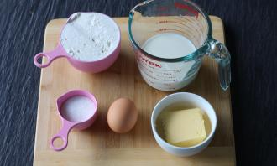
- 1. Have the children gather all ingredients.
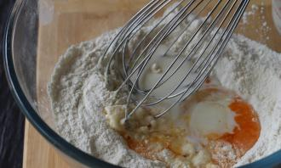
- 2. In a bowl, have them whisk flour and sugar. Beat in the egg and then milk a little at a time until batter is smooth and lump-free.
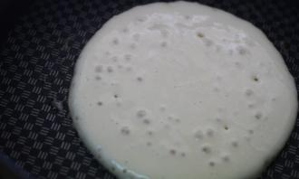
- 3. In a hot pan or flat grill over medium heat, brush butter over cooking surface and pour 1/4 cup measures for each pancake.
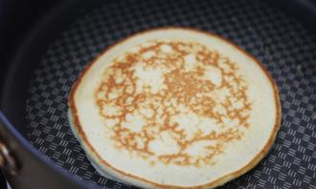
- 4. When large bubbles form on the surface, flip the pancake over and cook until lightly golden on the other side.

8- Pepperoni and Cheese Crescents
- Ingredients
- 1 (8-oz.) can Crescent Dinner Rolls –per 8 children
- Bag of Pepperoni slices
- Shredded mozzarella cheese
- Tomato sauce
- Cooking oil spray

- Preheat 375
- Spray your pan with cooking oil spray
- Each Child gets their own crescent triangle, 2 pepperoni slices, tomato sauce to spread on the bottom and 2 spoon full of cheese. Let them put the ingredients on the crescent roll and have them roll it up.
- Bake 10-14 Minutes
9- Quick & Easy Soft Pretzels
What you need:
1-1/2 cups warm water
1 tablespoon white sugar
5 teaspoons active dry yeast
4 cups all-purpose flour (plus some to flour work surface)
1/4 cup melted butter
1 teaspoon coarse salt
1 egg, beaten
Additional coarse salt to sprinkle on pretzels, as desired.
What you do:
Pre-heat oven to 425 degrees.
Mix water and sugar together in a bowl until sugar has dissolved and then add the yeast. Allow mixture to stand for about 5 minutes - until the yeast softens and begins to form a creamy foam.
In a separate bowl, whisk flour, butter and salt together until well mixed. Add the yeast mixture and stir with a fork until the dough starts to cling. Turn the dough out onto a floured surface and knead until smooth.
Cut dough into 15 equal pieces. Roll each piece between your hands into long ropes at least the thickness of a pencil. To make into traditional pretzel shape, make a large “U” shape and then connect the two ends, twist 2 to 3 times and bring down to the center of the U and press together. You can make any shapes you would like.
Place on baking sheet, brush with egg and sprinkle coarse salt over them, if you'd like.
Bake for about 8 to 10 minutes, until pretzels are golden brown. You will need a slightly longer cook time for thicker pretzels. Allow to cool on pan for 2 minutes. Enjoy!

10- Arctic Grapes
What you will need
1lb of seedlees green grapes
2 Tbsp. Jell-o Lime Flavor Gelatin
Ziplock Bag
Each child write name on bag
10 seedless grapes child
2 tsp of gelatin (spoons in class)
Shake well till covered
Freeze for 2 hours
Lets Eat
Use Assembly Line
To begin get the teacher to remove steams from grapes wash them and put them in a large bowl with spoon
Place green gelatin in a bowl with spoon
Let each child put their 10 grapes in their bag and pass grapes to the next child do gelatin the same
Place empty bowl at the end of the table for children to put their finished bags in to be froze
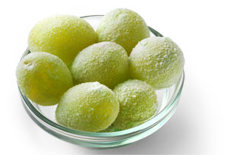
11- Marshmallow Carmel Rice Krispies Treats
**Afternoon before activity put one marshmallow on a stick per child and freeze**
7 ounce package of caramels
¼ cup of margarine
6oz of can sweetened condensed milk
Box of Kellogg Rice Krispies
Directions
- Put caramels, margarine, and sweetened condensed milk into a sauce pan and cook on low heat, stirring constantly until melted together
- Remove from heat
- Dip frozen marshmallows into mixture, then immediately roll rice krispies
- Let them cool on wax paper
- Store in refrigerator
- Enjoy
12- Milkshakes
PER 2 CHILDREN
- 4 Scoops of ice cream
- 1 Cup of milk
- Chocolate Syrup
- Strawberry Syrup
- Blender

Pour milk into blender
Add ice cream
Add chocolate syrup or strawberry syrup
Blend on high for 15 seconds or until well blended
Serve Immediately or freeze until ready to eat

13- Patriotic Snacker
1 Blueberry Jello Mix
1 Strawberry Jello Mix
1 Cup of Boiling Water
1 Cup of Cold Water
¼ Cup Small Marshmallows

- Have each child label a cup with their name.
- Mix blueberry jello mix with 1 cup of boiling water and 1 cup of cold water
- Mix strawberry jello mix with 1 cup of cold water
- Mix each mix in a separate pitcher until mix is dissolved
- Pour each mix in a separate 10 oz cup 1/3 way full
- Put marshmallows in red jello cup
- Freeze blueberry and strawberry jello cups with marshmallows
- After mixtures are frozen gently with a butter knife take out the blue jello and put on top of the red jello
- ENJOY

14- Simple Apple Pie
1 Tube of refrigerator biscuits (10 each)
11/2 -2 Apples
Cinnamon
Sugar

- Preheat oven to 350 degrees
- Peel Apples. Chop into small pieces
- Open tube of biscuits. Flatten 1 biscuits
- Mix cinnamon and sugar together. Dip apple slices in mixture. Cover all sides
- Place ½ of apple slice in the middle of flatten biscuit then fold the biscuit around the ½ apple slice
- Bake at 350 degrees for 10-12 minutes
- Cool slightly before eating.
Makes 10 apple pies
**Estimate amount of cinnamon and sugar, but we used about 5 tablespoons of each mixed in a small bowl. This was enough for 10 apple slices with some left over.

15- Puppy Chow Snack Mix
Need
- Pot
- Spoon
- Ziploc Bag
- 6oz Chocolate Chips (1/2 bag)
- ¼ Cup of Butter
- ½ Cup Peanut Free Peanut Butter
- 6oz Crispix Cereal (1/2 box)
- ½ lb of Confection Sugar
Directions
Melt chocolate chips, butter and peanut butter over medium heat, stir to blend
Give each child ½ cup of cereal in a bowl
Pour a spoonful of melted chocolate mixture on top of the child’s cereal aand have the child stir with their own plastic spoon
Pour 3-4 tablespoons of confectioners’ sugar in Ziploc bag
Add Cereal and shake vigorously until it breaks apart
16- Spaghetti Octopus Directions
Need
Hotdogs (1 hotdog per 2 kids)
Spaghetti Noodles
Pot
Water

Break spaghetti noodles in half
Cut each hot dog into 8 equal pieces
Push 5 Pieces of raw spaghetti into each piece of hot dog
Fill a 5 quart pot with water and sprinkle salt and let boil. Then add hotdog pieces skewered with spaghetti. Let boil for 7 minutes
17-Outer Space Cereal Bars
Need Per Child
- ½ tablespoon butter
- 1 cup mini marshmallows
- 1½ cups puffed rice cereal
- Ziploc bag
Give each child a Ziploc bag and have them put their name on the bag.
Heat water in a pan over hot plate. When water is HOT each child follows directions below…
Place butter and mini marshmallows in the Ziploc bag and seal shut. Put the bag in the hot water. Once butter and marshmallows are melted remove bag from the pan of water. Open bag and pour the cereal into the bag then seal shut. Children then knead the bag with their hand until the cereal is coated with the melted butter and marshmallow mixture. Then form in to shape of ball, square or rectangle. Refrigerate until cool.
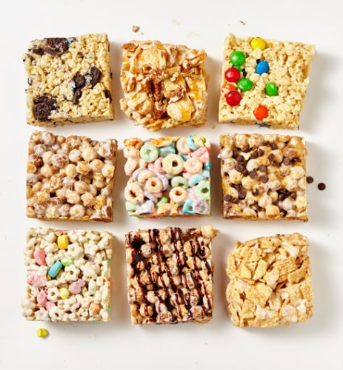

18-Apple Pizza Dessert

Ingredients
- Pastry for a single-crust pie
- 2/3 cup sugar
- 3 tablespoons all-purpose flour
- 1 teaspoon ground cinnamon
- 4 medium baking apples, peeled and cut into 1/2-inch slices
- TOPPING:
- 1/2 cup all-purpose flour
- 1/3 cup packed brown sugar
- 1/3 cup rolled oats
- 1 teaspoon ground cinnamon
- 1/4 cup butter, softened
- 1/4 to 1/2 cup caramel ice cream topping or caramel apple dip
- Vanilla ice cream, optional

Directions
- Roll pastry to fit a 12-in. pizza pan; fold under or flute the edges. Combine sugar, flour and cinnamon in a bowl. Add apples and toss. Arrange the apples in a single layer in a circular pattern to completely cover pastry. Combine the first five topping ingredients; sprinkle over apples.
- Bake at 350° for 35-40 minutes or until apples are tender. Remove from the oven and immediately drizzle with caramel topping or dip. Serve warm with ice cream if desired. Yield: 12 servings.

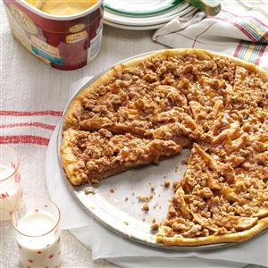
19-Carmel Apple Pie Cookies

INGREDIENTS
- 1 box Pie Crust (2 sheets)
- 3/4 cup Caramel Sauce
- 1 1/2 cup Apple Pie filling, chopped up
- 1 Egg White
- Sugar for sprinkling

DIRECTIONS
- Pre-heat oven to 350 degrees.
- Line a baking sheet with parchment paper and set aside.
- Layer one pie crust first with caramel sauce and then with apple pie filling. With the other pie crust, cut strips and place them on top of the first pie crust 1/4 inch apart.
- Use a 2.5 inch cookie cutter to cut the pie. You should get about 10-12 rounds. You could either bake the uneven sides (I do) or leave them as is.
- Whisk together 2 tablespoons water with the egg white, and brush the cookie tops with this egg wash. Sprinkle with sugar and bake for 20 minutes till the crust is golden brown.

20-Cheese Stuffed Corndogs

INGREDIENTS
Serves 8
8 slices cheese
8 hot dogs
8 wooden skewers
2 cups flour
1 teaspoon salt
1 teaspoon pepper
1 tablespoon baking powder
1 ½ cups milk
2 eggs
Oil, for frying
Ketchup and mustard, to serve

PREPARATION
1. Place a hot dog in the middle of a cheese slice.
2. Roll the cheese slice around the hot dog, then push a wooden skewer inside.
3. Place the cheese-wrapped hot dogs seam side down on a baking sheet. Freeze for 20 minutes.
4. In a large bowl, combine the flour, salt, pepper, baking powder, milk, and eggs, stirring until the batter is smooth and has no lumps.
5. Pour the batter into a tall glass cup for easier dipping.
6. Heat oil in a pot over medium-high heat until 375°F-400°F.
7. Take a frozen hot dog and dip it fully into the batter, lifting it out then rotating it to let excess batter drip off.
8. Using tongs, carefully place the battered dog into the hot oil, rotating it so that it fries evenly. Remove when golden brown, then pat with a paper towel to drain.
9. Serve with ketchup and mustard!
10. Enjoy!

21-Doughnuts

INGREDIENTS:
- Vegetable oil
- 1 ½ cups confectioners' sugar
- 3 tablespoons milk
- 2 teaspoons vanilla extract
- 1 tube Pillsbury biscuit dough

DIRECTIONS:
- In a heavy-bottomed pot, heat 1 inch of oil until it reaches 350℉ on a thermometer.
- Place sugar in a medium bowl and whisk to remove lumps. Slowly stir in milk, a little at a time, u
- ntil you have a smooth glaze. Stir in vanilla. Cover with plastic wrap and set aside.
- Separate the biscuits and lay flat on a cutting board. Using a small, round cookie cutter, cut out a small circle from the center of each biscuit.
- Cook the donuts in batches in the hot oil for about 1 minute per side, or until golden. Drain on a wire rack. Repeat with donut holes, but with less frying time.
- While still warm, dip donuts in glaze, turning to coat completely. Return to wire rack and allow excess glaze to drip off. Eat while still warm.

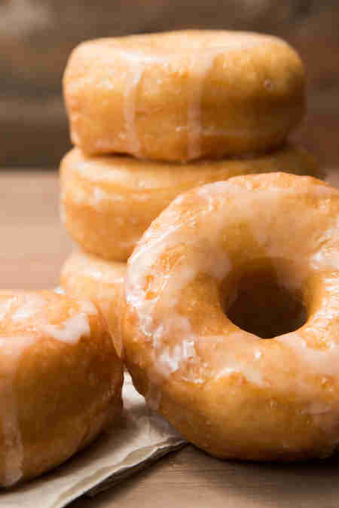

22- Hawaiian BBQ Chicken Pizza
Yield: 1 12-inch pizza
Ingredients
- 1 lb pizza dough, homemade or store bought
- 12 oz boneless skinless chicken breasts
- 2 Tbsp olive oil, divided
- 3/4 cup barbecue sauce, divided
- 4 slices bacon, cooked and chopped
- 2 cups (8 oz) low-moisture mozzarella, shredded
- 1 cup chopped fresh pineapple (chop into small pieces)
Coupons
- 1/3 of a medium red onion, sliced thin and run under cool water to remove harsh bite
- 1/4 cup cilantro, chopped or torn
- 1 cloves garlic, minced
- Freshly ground black pepper

Directions
- Preheat oven to 475 degrees.
- Preheat a grill to medium-high heat. Brush both sides of chicken lightly with 1 Tbsp of the olive oil and season both sides with salt and pepper. Grill until cooked through, rotating once halfway through cooking, and brushing with 3 Tbsp of the barbecue sauce during last 1 - 2 minutes of grilling. Remove from grill and set aside to cool 5 minutes.
- Spread pizza dough out on a floured sheet of parchment paper over a pizza tray to a 12-inch round (if you prefer a crisp crust, preheat a pizza stone in oven and transfer pizza on parchment using a pizza peel to preheated stone). In a mixing bowl whisk together remaining olive oil and garlic. Brush entire surface of dough with olive oil mixture and let rest 10 minutes.
- Cut chicken into cubes. Brush dough with remaining barbecue sauce (1/2 cup + 1 Tbsp). Top with 1/3 of the mozzarella then top with chicken, pineapple, bacon and red onion. Sprinkle with remaining mozzarella and season with freshly ground black pepper. Bake in preheated oven until crust is golden, about 11 - 13 minutes. Slice and serve warm topped with cilantro.

23- Homemade Ice Cream

Ingredients
2 cups heavy cream, chilled
1 (14 ounce) can sweetened condensed milk, chilled
1/2 teaspoon vanilla extract
Directions

In the bowl of an electric mixer, whip the cream until stiff peaks form. On low speed, mix in the condensed milk, vanilla, and any flavorings.
Pour into a resalable container, cover the surface with plastic wrap, then seal. Freeze for at least 6 hours, or until firm. Keep stored in the freezer.

24-MINI DEEP DISH PIZZAS

INGREDIENTS:
- 4 Old El Paso™ flour tortillas for burritos (8 inch)
- 1 cup pizza sauce
Coupons
- 3/4 cup shredded mozzarella cheese
- 1/4 cup freshly grated Parmesan
- 36 mini pepperonis

DIRECTIONS:
- Preheat oven to 425 degrees F. Lightly oil a 12-cup muffin tin or coat with nonstick spray.
- Working one at a time, lay tortilla on a flat surface. Using an empty can, cut 3-4 medium circles, pressing firmly enough in a rocking motion to cut through the tortilla.
- Fit a tortilla circle into each of 12 muffin tins, pressing carefully to make sure there is an opening in the center. Scoop 1 tablespoon pizza sauce into each muffin tin. Sprinkle with mozzarella and Parmesan cheeses, topping with 3 mini pepperonis each.
- Place into oven and bake for 10-12 minutes, or until cheese has melted.
- Serve immediately.
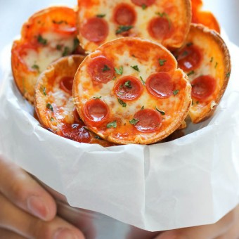

25- Pepperoni Pizza Sticks

Ingredients
1 package of string cheese (12 count)
24 Pepperoni Slices
1 can crescent dough sheet
1 Cup marinara sauce
Directions
Heat toaster oven to 400°F. Unwrap string cheese, and cut a 2-inch slit along one side of each, leaving ends intact. Cut pepperoni slices in half, and insert 4 halves into each cut side of mozzarella sticks.
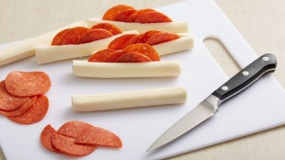
On large cutting board, unroll dough; cut short side into 12 equal strips. Starting at one end of mozzarella stick, wind one strip of crescent dough around cheese, completely covering cheese. Seal ends, and place on ungreased cookie sheet. Repeat for remaining dough and mozzarella sticks.
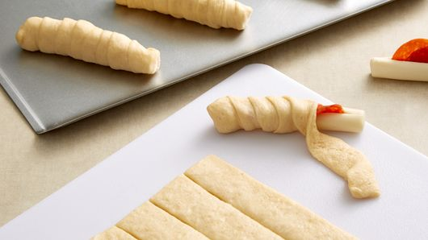
Bake 10 to 12 minutes or until golden brown. In microwavable bowl, heat marinara sauce covered on Medium-High (70%) 1 to 2 minutes or until warmed through. Serve immediately with warm crescent sticks
26- Pizza Bombs
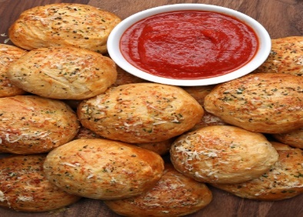

INGREDIENTS
Yields: 16 balls
1 can (16.3 oz) biscuit dough
Marinara sauce
Pepperoni
Mozzarella, cut into cubes
3 tablespoons butter, melted
2 cloves garlic, minced
Salt and pepper, to taste
1 tbsp Italian seasoning
Shredded parmesan cheese, for topping

PREPARATION
1. Cut each biscuit in half. Press each half into a circle with your thumb.
2. Place a small dollop of marinara sauce, 1 pepperoni, and 1 cube of mozzarella on each biscuit round.
3. Bring the edges up and over, pressing them together and being sure to leave no gaps for the filling to leak out. Lay the pizza bombs on a baking sheet lined with greased parchment paper
4. Combine melted butter, garlic, salt and pepper, and Italian seasoning in a small bowl. Brush the butter mixture onto each pizza bomb and top with parmesan.
5. Bake at 375 for 15-20 minutes (until biscuits have nicely browned).
6. Once pizza bombs are cool enough to handle, serve immediately. Enjoy!

27- Pizza Waffles
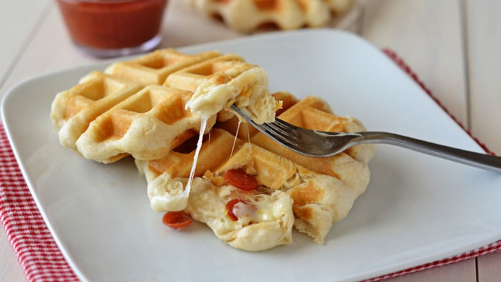

Ingredients
1 can (16.3 oz) Pillsbury™ Grands!™ Flaky Layers refrigerated Original biscuits
8 slices (1 oz each) mozzarella cheese
1/3 cup mini pepperoni slices
2cups pizza sauce

Directions
- 1Spray waffle maker with cooking spray; heat waffle maker.
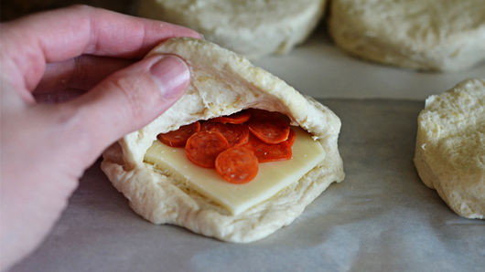
- Separate dough into 8 biscuits. Cut slit on 1 side of each biscuit, forming a deep pocket. Place 1 slice of cheese into each pocket. Top cheese with 6 or 7 pepperoni slices. Press dough around edge to seal each biscuit.
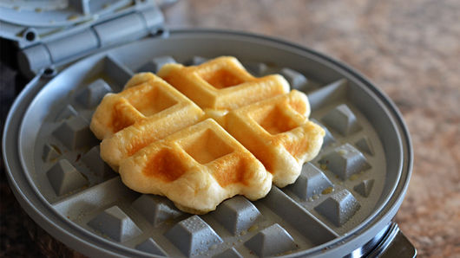
- Place 1 biscuit on center of waffle maker. Close lid; cook 3 minutes or until waffle is golden brown.
- Repeat with remaining filled biscuits. Serve with pizza sauce.

28- Quick and Easy Calzones
Ingredients
- 13.8-oz refrigerated pizza crust
- 1/2 cup pizza sauce
- 1 cup shredded mozzarella cheese
- 18 slices pepperoni
- 1 tablespoon butter, melted
- Italian seasoning, to taste
- grated parmesan cheese, to taste
Instructions
- Preheat the oven to 400 degrees. Spray baking sheet with nonstick cookie spray (or use a baking mat).
- Roll out the pizza crust, and cut it into 6 equal-sized squares.
- In the middle of each square, place a portion of the pizza sauce, shredded cheese, and pepperoni.
- Fold the dough over into a triangle, and use a fork to press along the edges of the triangle to seal it closed.
- Place calzones onto the prepared baking sheet. Brush the top of each calzone with butter, then sprinkle with Italian seasoning and grated parmesan cheese.
- Place in the oven and bake for 10-12 minutes, or until tops are golden brown. Serve warm with extra pizza sauce for dipping.
29- S’MORES PINWHEELS

Instructions:
10 oz miniature marshmallows
¼ cup salted butter
5 cups Rice Krispies cereal
¾ cup graham cracker crumbs
7 oz jar marshmallow creme
1 1/2 cups miniature semi-sweet chocolate chips

Directions:
1. Melt the marshmallows and butter in the microwave in a medium bowl for 1½ minutes or until completely melted, stirring halfway through.
2. While the marshmallows are melting, mix the Rice Krispies and the graham cracker crumbs together in a large bowl.
3. Stir the melted marshmallow mixture into the Rice Krispies.
4. Line a 10×15 jelly roll pan with parchment paper and spray with non-stick spray.
5. Press the Rice Krispies in an even layer to fill the jelly roll pan (or as I did, a 13 x18 half-sheet pan that I filled ¾ full),
6. Spread the marshmallow creme evenly over the cereal layer and top with the mini chocolate chips chips.
7. Place the pan in a 200F oven for 2 minutes, just long enough to start melting the chocolate chips. Remove from the oven and spread the chocolate out in an even layer over the marshmallow creme.
8. Using the parchment paper, carefully roll the Rice Krispies treat into a tight log.
9. Refrigerate for one hour and slice into pinwheels once the chocolate and marshmallow are set.
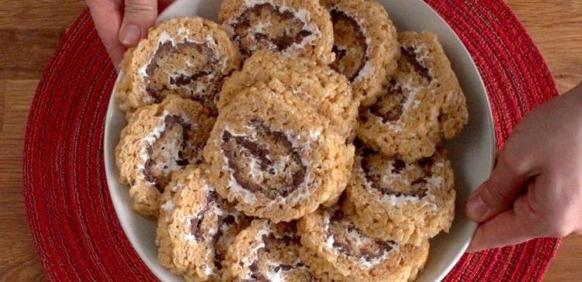

30- Sugar Cookie Tacos
Serves 12
Prep Time: 20 minutes
Total Time: 35 minutes

INGREDIENTS
- 1 – 16.5-ounce roll refrigerated sugar cookie dough
- 2 tablespoons granulated sugar
- ¾ teaspoon cinnamon
- 1 cup heavy whipping cream
- 3 tablespoons granulated sugar
- 2 cups fruit, chopped

DIRECTIONS
- Preheat oven to 350 degrees Fahrenheit (175 degrees Celsius). Wrap a rolling pin, empty paper towel rolls or other rounded forms in foil.
- In a small bowl, combine the 2 tablespoons of sugar and the cinnamon.
- Slice the cookie dough into 12 ½-inch thick slices.
- Press each cookie dough slice into the cinnamon-sugar, then place on a baking sheet. There should be about 6 cookies per sheet, evenly spaced.
- Bake the cookies until golden brown, following the package instructions.
- Gently remove cookies from the pan and immediately drape over the foil wrapped forms. Press gently to mold the cookie to the roll. Allow to cool completely before removing.
- In a medium bowl, beat the heavy cream and 3 tablespoons of sugar together on medium-high speed, until stiff peaks form.
- Fill each cookie with 2 tablespoons of the whipped cream, and top with chopped fruit.
31-White Pizza
A classic white pizza with a whole-wheat blend crust is the perfect cheesy, oily, and garlic-y pizza for any day of the week!
Servings: 1 13-inch pizza
INGREDIENTS
- 1 recipe for whole wheat-blend pizza dough
- 3 tablespoons olive oil
- 3 cloves garlic, minced
- 2 cups shredded whole-milk mozzarella cheese
- 1 1/2 teaspoon Italian seasoning
- Salt, to taste

INSTRUCTIONS
- Preheat oven to 450 degrees Fahrenheit and lightly flour a 13-inch pizza pan.
- Using your hands, gently stretch the dough in the pizza pan. Leaving a 1-inch border from the edge, brush olive oil and minced garlic all over the dough. It's okay if the minced garlic doesn't cover all the space.
- Sprinkle mozzarella cheese all over top then the Italian seasoning and salt.
- Bake for 12-13 minutes or until cheese is bubbling and the crust has browned around the edges.
- Let cool for about 5-10 minutes before slicing and serving.

