Art Websites
- https://artfulparent.com/kids-arts-crafts-activities-500-fun-artful-things-kids

- https://www.pinterest.com/explore/art-project-for-kids/

- https://www.pinterest.com/applenan/school-age-kid-crafts/

- https://www.pinterest.com/ldblair/arts-crafts-school-age/

Art Activities
- Airplane Mobile
What you need:
- Water bottle
- Scissors
- Masking Tape
- Cardboard
- Paper Mache
- Paper
Step 1: Cut out the wings and parts of the tail from thick cardboard, and attached them to the fuselage with the masking tape.
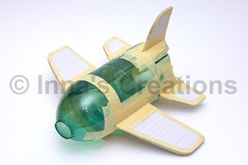
Step 2: Build the landing gear by stacking plastic bottle caps and fixing them with the masking tape: two caps for the front and six for the main unit.
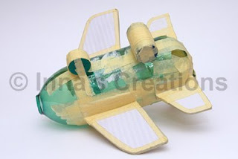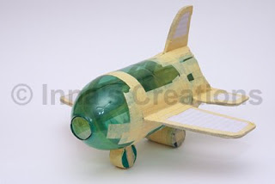
Step 3: Plug the bottleneck with a foamed plastic ball, but a crumpled paper ball will also do.
Step 4: Cover everything with three or four layers of papier-mache, that is small pieces of paper dipped into white craft glue mixed with some water. We often use copy paper scrap. Although this sort of paper isn't the best choice for papier-mache, it allows getting thick layers quickly — for impatient little craft makers :) When coating the bottle, leave a strip of uncovered plastic in front of the aircraft, that would be the cockpit. The pilot should be able to see the way!
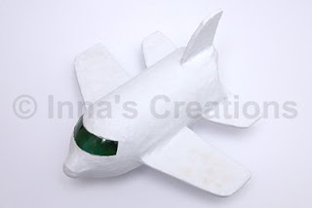
Step 5: Decorate, of course. You may want to glue pictures of your family members into the windows. Be creative as much as you can at this stage.

- Clothespin Airplane Art
Plane 1: You Need
Clothes Pin
2 Popsicle Sticks
1 Half Popsicle Stick

Each child should paint or decorate all of their parts for the plane. Then they should glue a craft stick on top and bottom of the clothespin as wings and half of the popsicle stick on the back as the tail.

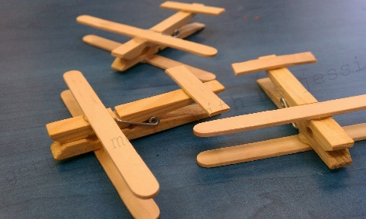

Plane 2: You Need
1 Clothespin
3 Foam Craft Sticks
Glue
Scissors

- Cut the first craft stick in half but a curved ending to match the other side, the cut the tip of the other half off. Have them color their clothes pin
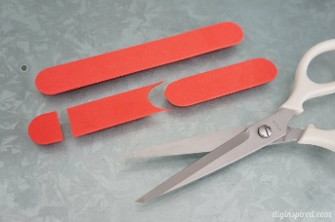
Then glue the 2 whole craft sticks on the top and bottom of clothes pin toward the part that opens. Then they will glue the little stick they cut to the top of the clothespin towards the back. The tip piece will be glued to the center of the tail.
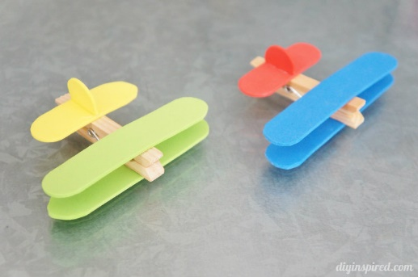

3-How To Make Decorative Confetti Bowls
What you need:
– Balloon
– Confetti
– Mod podge
– Sponge
– Bowl

Each child should blow up their balloon, then insert it on to the bowl so it's sturdier to work with.
Then they need to add Mod Podge to the top half of the balloon with a sponge, then sprinkle confetti all over, they can remove their balloon from the bowl and hold it to add the confetti on the sides.
Let it dry and then they can add another coat of glue and confetti, you will need to add several coats until you achieve a thick coat. Let it dry for until the next day.
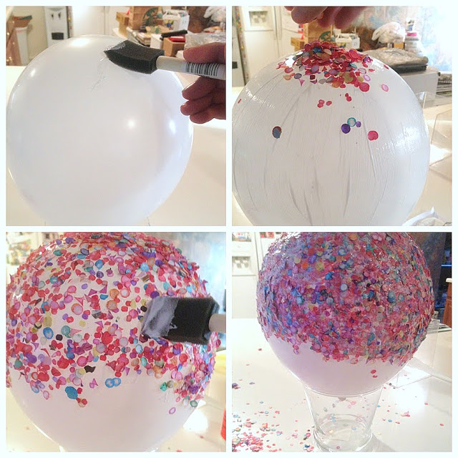

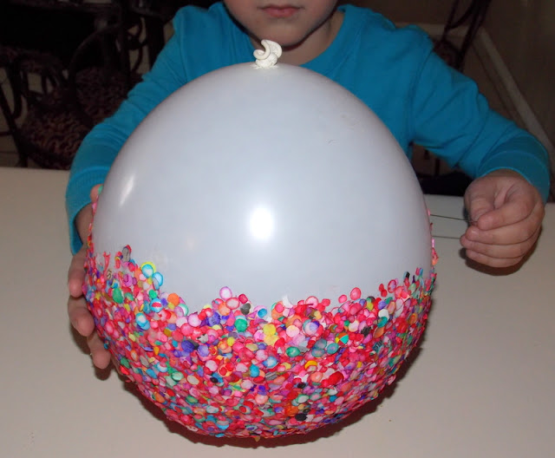
Have them turn their balloon and Pop it with a needle,
Now you'll have a colorful bowl!
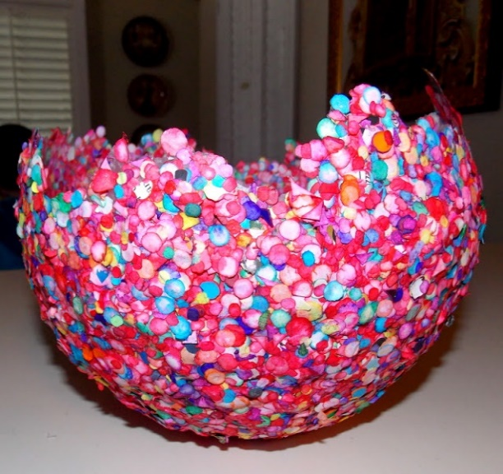

They could either keep it with irregular edges, or they can cut them as I did.
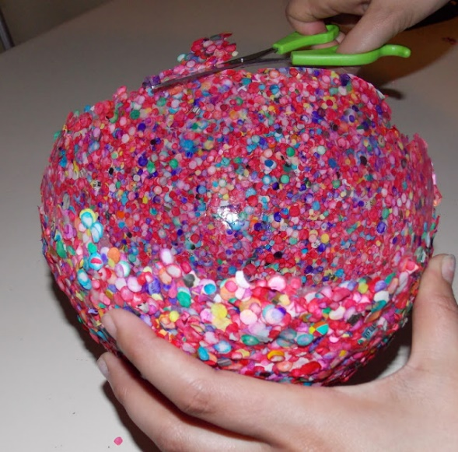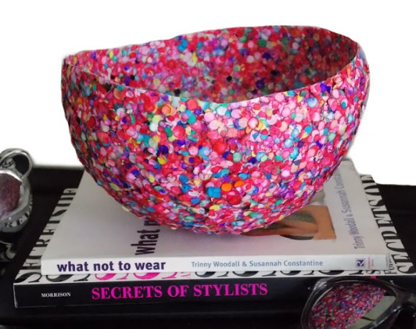
That's it!
4-Glowing Rainbow Bouncy Balls:
Have about 6 do it at once and all different colors.

To Make Each Ball Combine:
- 1/2 Tsp of Borax
- 4 Tbsp of Corn Starch
- 4 Tbsp of warm water
Have each child combine in a small bowl, mixing until all ingredients are dissolved

In a separate Bowl Have Child Combine:
- 1 Tbsp white glue
- 1 Tsp Fluorescent or Glow in the Dark Paint
Mix well until the paint is completely blended into the glue. If you have homemadeglow in the dark glue on hand you can also use that and skip the mixing.
Once the ingredients of both bowls are well mixed combine the two bowls. Allow the ingredients to react by themselves for a minute before stirring them. As they stir a sticky hard, slimy material will form.
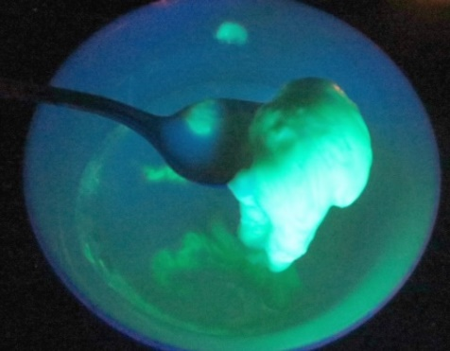
Have the child roll the material up into a ball.
As they roll the material it will lose it's sliminess and become dry and rather hard, yet still moldable
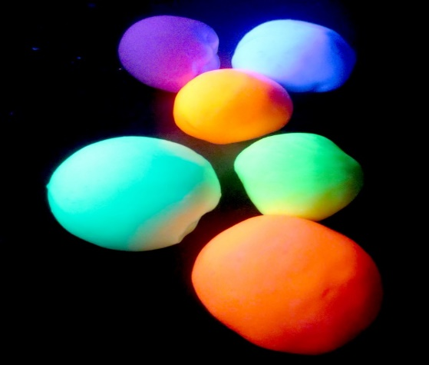
Have each child break apart the ball into about 6 pieces to make 6 RAINBOW bounce balls

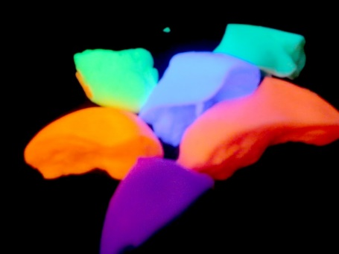
Then have the children take the 12 pieces and switch with a different person so they will have several different colors and work the varying colors together. We stretched and pulled them into a RAINBOW before rolling them together to form our bouncing balls. The stretching and pulling was very FUN!

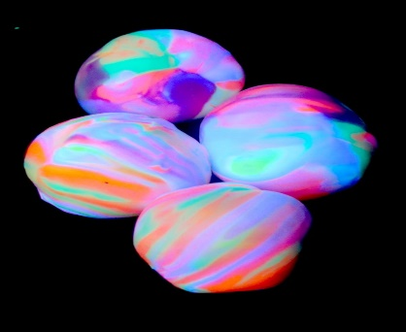
5-Canvas Painting
One of the Art Projects for this summer is Canvas Painting “Flight Theme”, this means anything that flies such as airplane, jet, rocket, etc.… Please have the children know what they are drawing and practice on paper. When they have perfected or are comfortable with their drawing have them draw it on the canvas first. After they have drawn the air craft of their choice on the canvas make sure they PAINT it!

**Remind the children the best art work throughout the summer will be chosen for a Center Art Gallery.
6- Kites

Devil's Kite (Super Easy Paper Kite That Really Flies!)
Turkish kite called "Seytan Ucurtmasi", which means "Devil's Kite"

You'll need a few easy to find household items:
- Square paper of any kind and size. Something light is better. (Even though I'm gonna use origami paper here, newspaper works great)
- String
- Scrap plastic bag for the tail (if you can't find a plastic bag around, you can use another piece of paper)
- A piece of sticky tape to strenghten the briddle points (optional)
- Small piece of cardboard for the string winder (optional)

Making the Kite
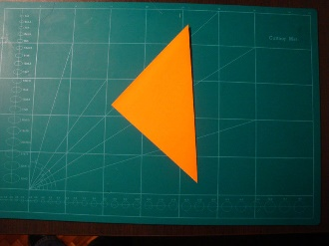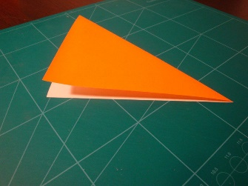
Fold the square in half along the center diagonal line. Fold so that the blank side of the paper is inside, and the color side is visible.
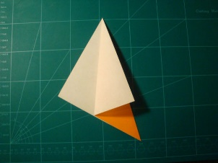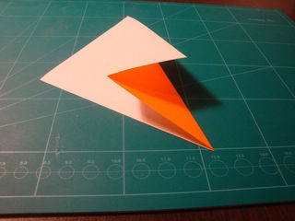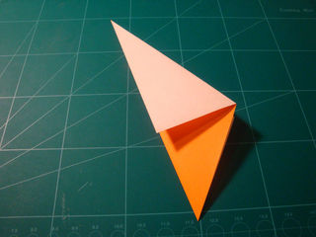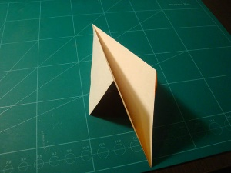

Now take one edge and make a fold to the centerline as you may see in picture. Turn the paper and repeat the step for the other side.

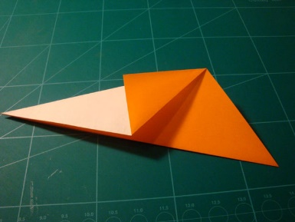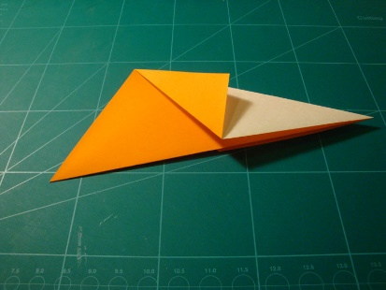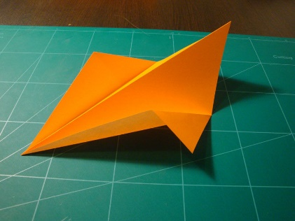
Fold the small corner to the center line. Repeat it for the other side as well.
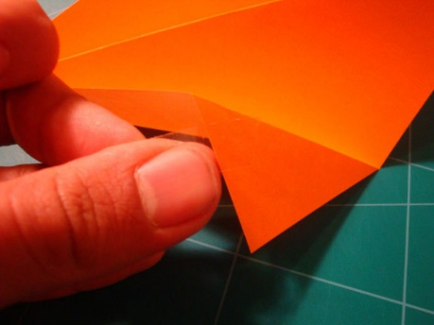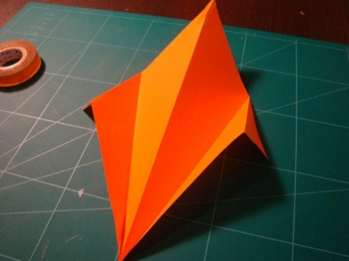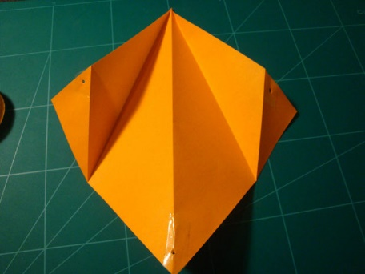
Use some tape to strenghten the sides you see at the pictures. After that, use a paper punch or scissors to make holes at the points.

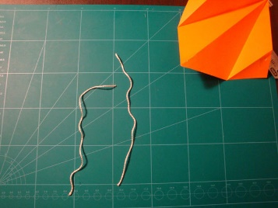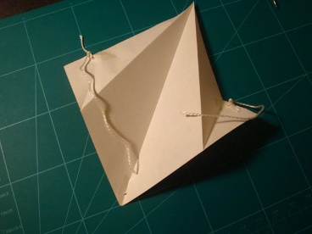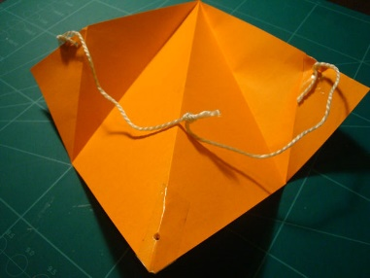
Cut two 20 cm (8 inch) strings. You'll tie these to the two holes at the parts, which are looking like wings.

Making the Tail
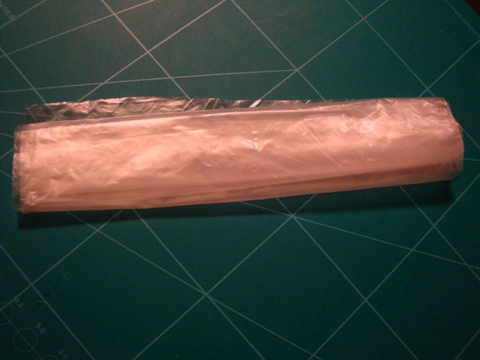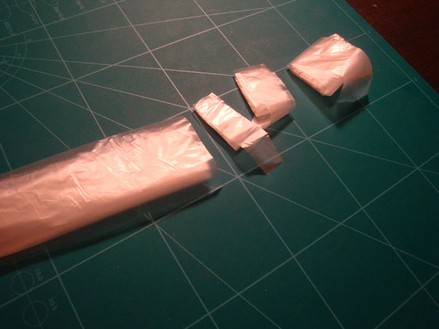

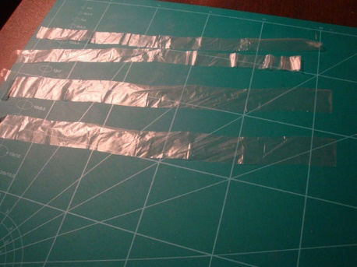 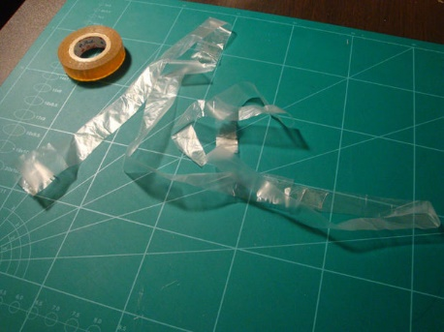 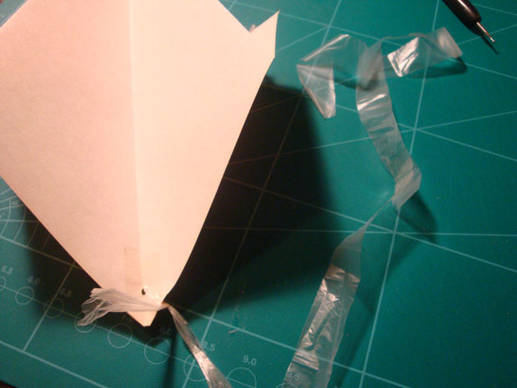
Fold the bag a few times and cut 2 pieces of it. Open up the pieces and you'll get 4 longer bag parts. Stick them together with a piece of tape to make it even longer and finally attach it to the back of the kite (where you punched a hole before)

Making a Winder
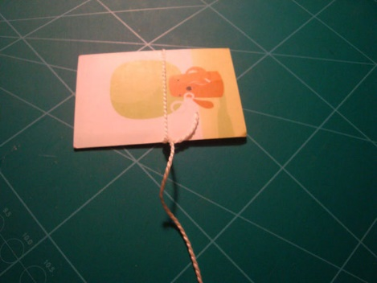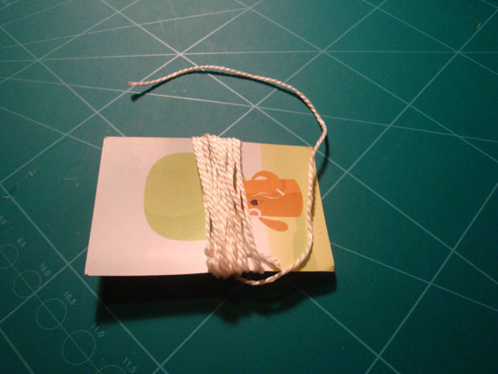
Making a winder is not a big deal. Just wrap the string around some piece of cardboard or even a pen and attach the end of it to the briddle of your kite.

Paper Kites

You will need:
String (butchers twine works well or button thread)
Light weight wood strips
Paper ( We used tissue paper layered double, but you can also use newspaper, crepe paper, gift wrap, or any light weight paper lying around the house)
Glue (We used those scrapbooking instant glue to make ours which is SUPER fast)
Scissors
Paper Cutter (Optional, but handy)

Step 1: Measure and Cut Your Wood

Make your stick and cut it in two. In general kites measure 20+ inches by 40+ inches which is a 5 foot long stick if you do the math. You can harvest sticks or brush out of your back yard for free After you measure the stick, cut it. You can use a paper cutter or any basic cutting instrument that gets the job done.

Step 2: Notch the Ends

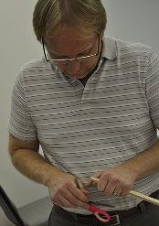
With a pair of scissor notch each of the four ends to give the string something to lay in when you start tying it together.

Step 3: Tie the two sticks together (Make the Frame)

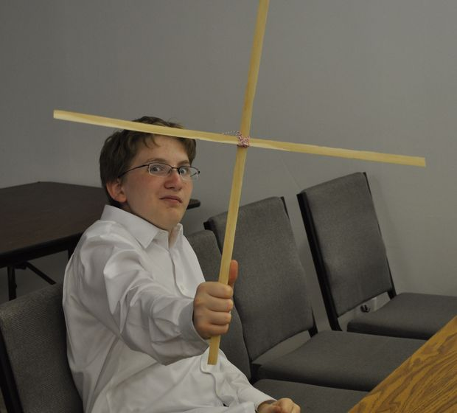
With string, wrap the two sticks together at the half-way point. You can do this be doing 5-6 cross hatches and tying a simple, but tight granny knot.

Step 4: Tie String Around the Edges
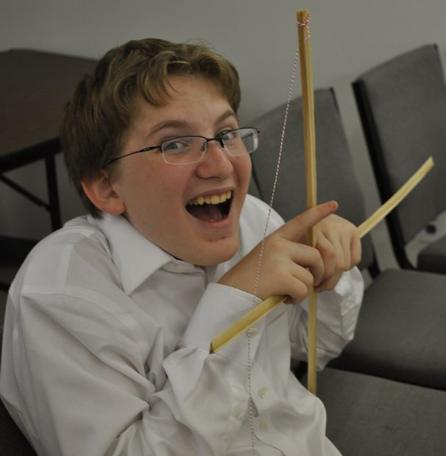
Taking one point, use your notch to act as a hold point for the string. Wrap the thread or twine several times around and move to the next point. When you get done you should have all 4 points of the kite connected.

Step 5: Glue the Paper Together
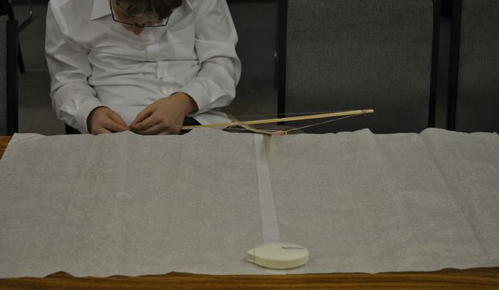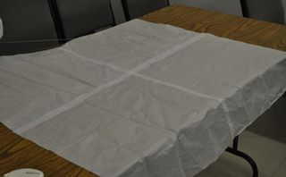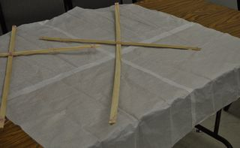

So, if you read kite making directions they talk about using paste glue and letting it drive overnight. We all cheat and use instant scrapbooking glue/tape you can buy at Michaels, but. Glue your tissue paper (double sheets is better) or any other light weight paper you have lying around (newspaper, computer paper, crepe paper, wax paper...etc.) together with 2 rows of glue. Your final area should be bigger the the kite frame by at least 1 inch).

Step 6: Trace Around the Kite Frame 2 inches wider.
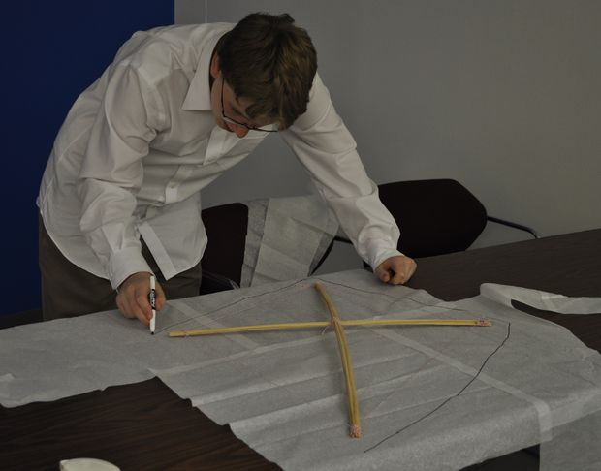
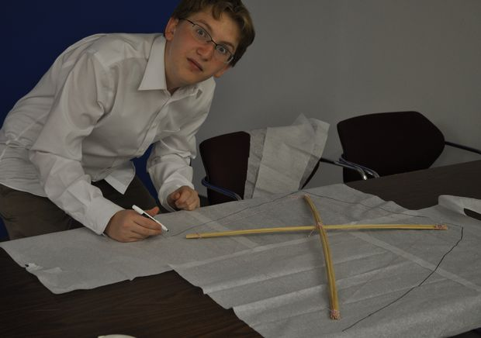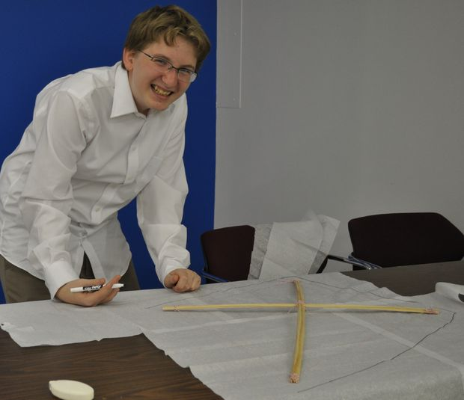
With a pen trace around the kite frame an extra 2 inches.

Step 7: Cut Out Your Paper
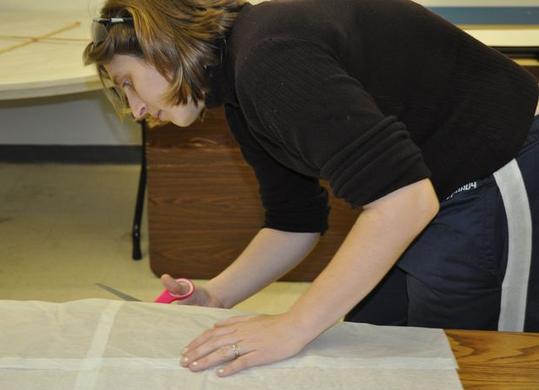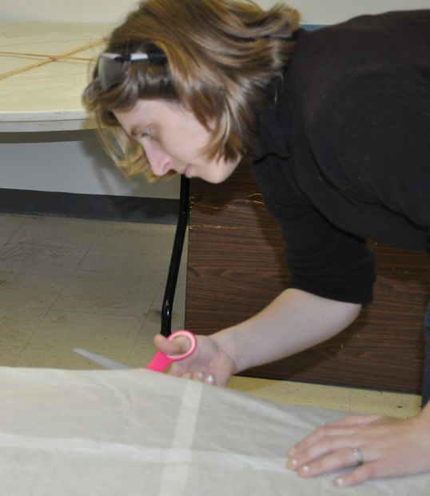
Taking your scissors, cut out the diamond you just drew with your marker.

Step 8: Color Your Kite
This is the most fun part in my opinion. Crack open your box of markers, crayons, or any drawing instrument and make your design. Mine is done in crayons (most fun), but other people used more adult tools like markers...etc. As long as you have fun. That's what counts.

Step 9: Tape the Paper to The Frame

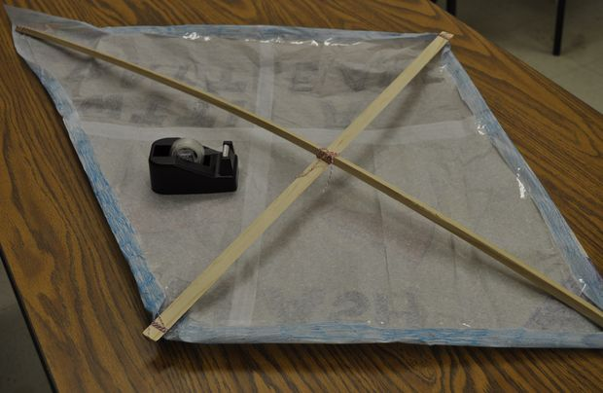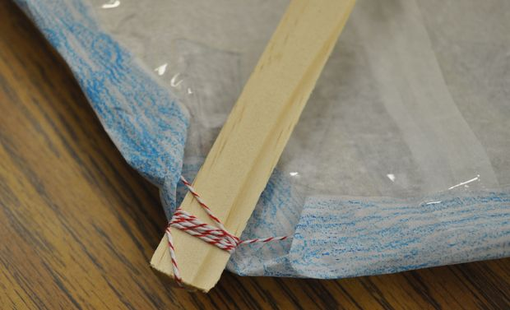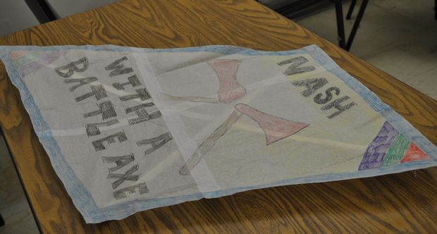

Once you have finished your design, place it under your frame with the picture facing outward underneath. Tape the paper around the string, working your way around. You need to fold the corners down to make it easy to attach anything you might need later like the bridle or a flashy ribbon tail.

Step 10: Attach the bridle and string to fly it.
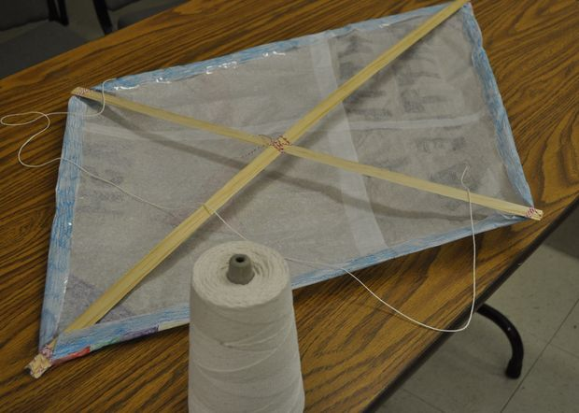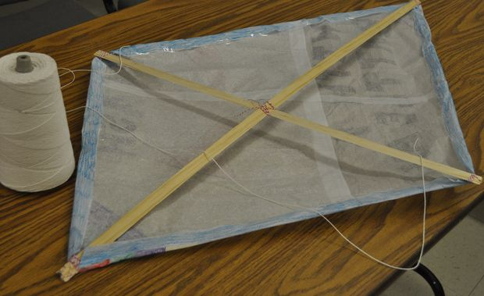
Now that you've finished your kite, you need to fly it. To do this, you need to attach a piece of string called the "bridle" from one side to the other. The piece should be fairly long and form a triangle with the base. This is how you control the kite to fly it. In the middle of the bridle or piece of string, tie your kite line to fly it. At least 100 ft. is ideal, many kite lines are closer to 500 feet.

Step 11: Optional Last Step: Add a Tail
As a fun optional last step, add a tail from the bottom with ribbon, tissue paper, or paper. People will tie all kinds of things to the end of their kite to give it stability. Viola, you have the perfect instant paper kite. Happy flying! Go enjoy this beautiful windy fall weather we're having.

Stunt Kite
You'll need
Materials:
- Paper (maybe A4, A3, or something similar)
- String/Thread
- something to cut the string

Step 1: fold and rip
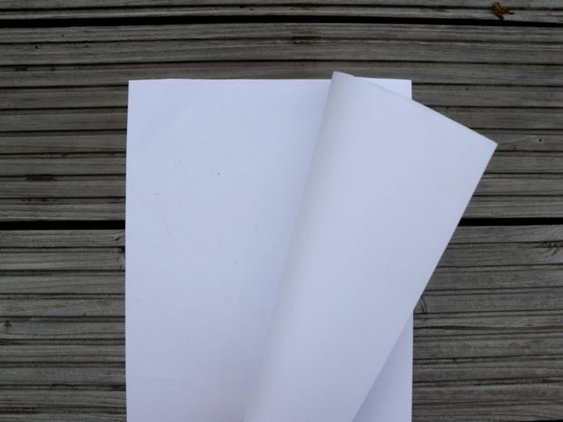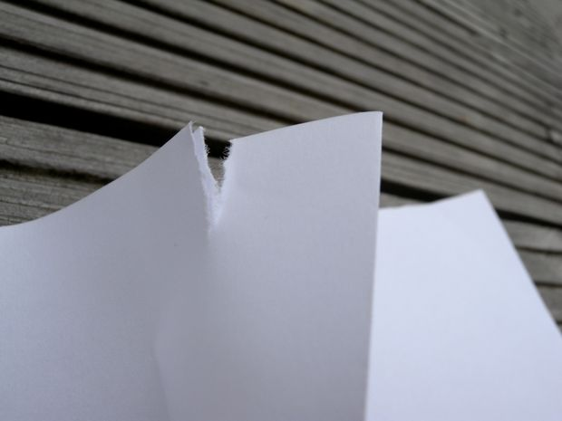
Fold the paper in a half.
Rip a little rip where your fold is. One at the top, one at the bottom.

Step 2: first string
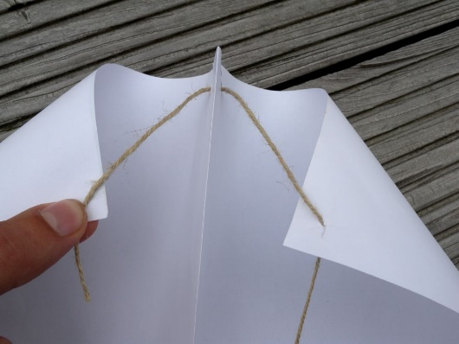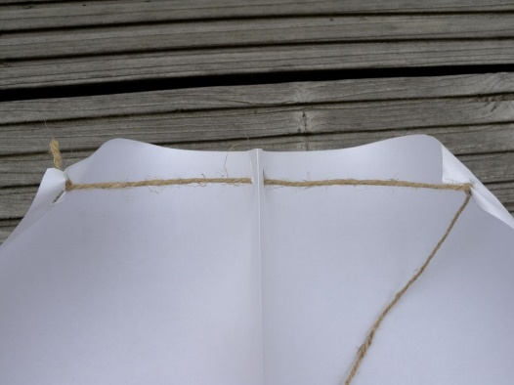
Make a hole at the upper corners of the (unfolded) paper. So the fold is in the middle of the two holes.
Put the string through the right hole first.
Now measure how much thread you need. The corners of the page are bent to the inside (not to much).
Make a knot at the right hole, go through the upper rip, go through the left hole and make a knot there.
Now you can cut the sting at the length you want it.

Step 3: second string
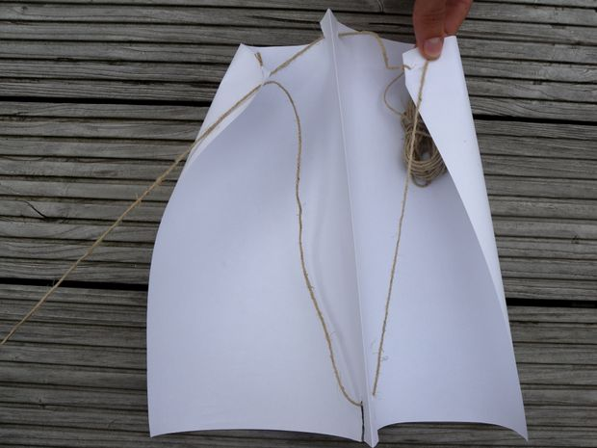
Repeat the last step for the second string. Now you start at the left and use the bottom rip. Use the holes you made before.
Cut the sting at the same length as the first.
Finished.
Now you can experiment with the length of the stings to find the best proportions.

Diamond Kite
You will need: scissors, a ruler, three garbage bags, a pencil, tape and two wooden dowels. (The dowel for the spine should be 10 millimeters thick and 95 centimeters long, the dowel for the spar should be 6 millimeters thick and 90 cm long). You should also have a roll of string.

Dimensions of the kite sail

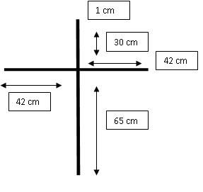

Using the garbage bags, make a 1x1 meter plastic sheet. If the garbage bags are too small, then cut them open and tape a few together using strong tape.

Draw on the lines that represent the spar and spine as shown in the picture according to the dimensions. If you don't want to draw then tape on some string and use them as guide lines. (remember to take off after cutting)

Preparing to cut the sail

Once youve drawn on the two lines that represent the spar and spine. Join the ends of the lines to form a diamond shape. Again if you don't want to draw, just tape on some string and use that as guide lines. (remember to take them off once finished cutting)
*Tip- Try to be accurate as you when you cut and place of the dowels, if you’re not it might affect the stability of your kite.

Cut out your sail

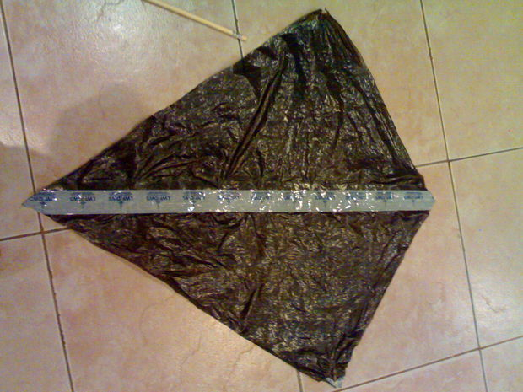
This is how it should look when it is finished

Attach the spar and spine to the sail
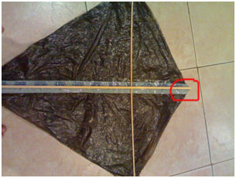
Tie or glue the two dowels together but make sure they match the dimensions and then place it on the sail of the kite. Place it on the kite and attach them to the sail at the ends, where its marked in the picture. Do this at each corner.

Attach the bridle
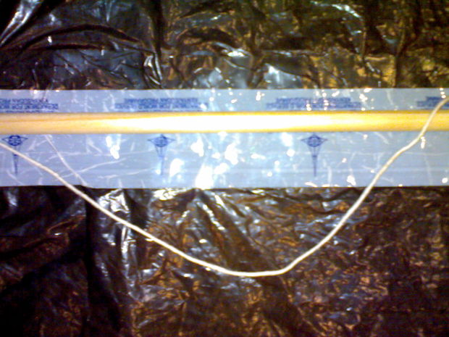
Cut a piece of your flying string.Tie one end to the point where the spine and the spar meet and then tie the other end 15 centimeters from the joint on on to the spine. The string use should give you about a 6 cm of slack. You can also tie two strings from the each end of the spar and to the bridle in the middle. This creates extra stability. Next tie your flying line on to the bridle around the middle. Now your string is ready.

Make the tail
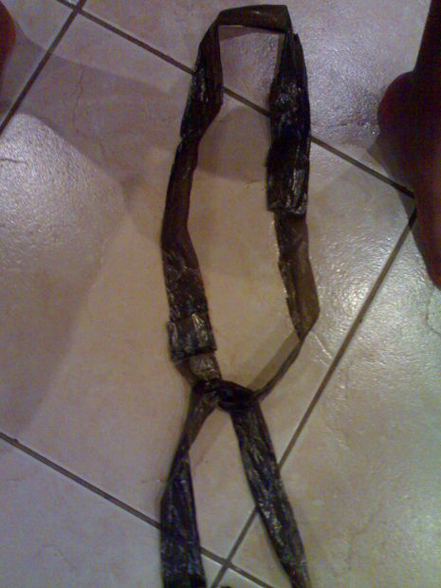
The final thing is attaching the tail. It should be around six times the length of your kite. Take a garbage bag and cut into strips. (No need to be accurate). Then take the strips and make a ring with them, then loop them through each other.

Final touches to the tail

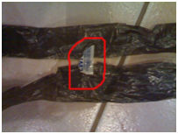
You might want to tape the two sides of the loop together to keep it steady and create more air resistance. Finally tie your tail to the kite by putting it under the spine and then tying it to the spine.

In the end...

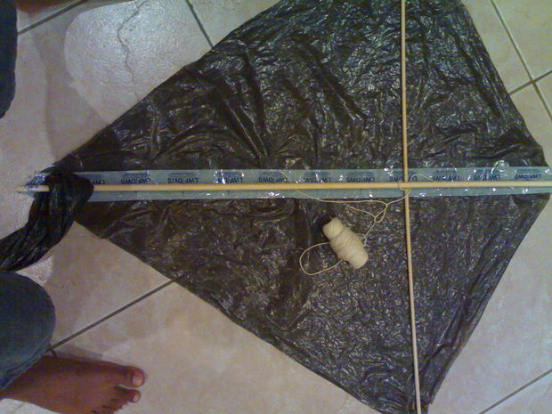

Your kite should look something like the one shown here and so now your done and can go fly your kite

7-Magic Drawing Paper

Materials:
- White Paper
- Crayons
- Black Nontoxic Paint
- Dish Soap
- Paint Brush
- Popsicle Stick/skewer
Step 1: With crayons color the whole white piece of paper with different colors so no of the white is showing.
Step 2: Put a drop of dish soap in your black paint and mix
Step 3: Paint the whole piece of paper with the black paint
Step 4: Let Dry COMPLETELY
Step 5: After the black paint is dry use the end of the popsicle stick/skewer and draw a picture.

8- Magic Glass Plates
What you will need:
Mod Podge Glossy
Paint Brush
Water
Glass Cleaner
Paper Towels
Thin White Paper with Childs Name and Magic Design
Glass Plates
Scissors
Can or Jar for Drying Plate
Pencil

- Each child should write their name in the middle of their sheet of paper and then decorate around it with anything that deals with magic.
- Then have them clean the bottom of the glass plates with glass cleaner and paper towels. Make sure the plate is dried off well.
- Have them trace around the plate with a pencil on the paper they have drew.
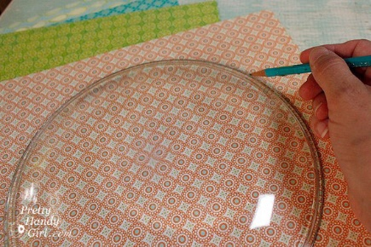

- Then each child should cut out their circle and snip four slits into the circle but NOT all the way to the center.
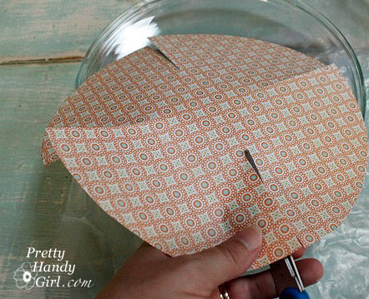

- After that they need to snip four more slits centered between the first set of slits. You should end up with eight cuts equally spaced.
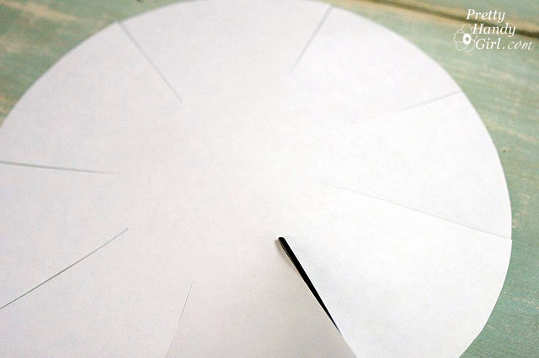

- With a paint brush let them cover the bottom of the plate with mod podge.

- Center the cutout circle onto the bottom of the plate, pattern side down. Gently press the paper onto the plate allowing the paper to overlap slightly at each slit.

**Don’t forget to remind the children that the best art projects throughout summer will be selected to be in the Centers Art Gallery at the end of summer.**

9- Painting on Glass Stones
What you need:
Glass stones
Paint
Little Paint Brush

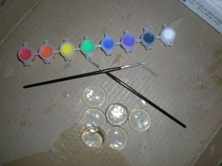
Have the children paint whatever they like on the flat side and let them dry.
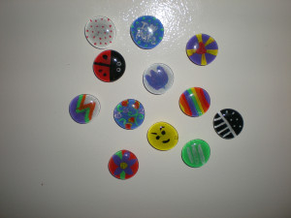
** Don’t forget to remind the kool kids you will be selecting the best art projects thru the summer for Art Exhibit at the end of summer camp. **

10-Piggy Bank Airplane

For this project, you’ll need:
- empty plastic bottle (we used a 16.9 ounce water bottle)
- card stock paper (we used white and blue)
- two-sided tape
- scissors
- Pencil

1. Make a Coin Slot
Have the child cut a rectangular slot about 1 inch long and a ½-inch wide in the side of the bottle. This is where they will drop coins into the piggy bank, so make sure it’s large enough to fit at least two quarters side-by-side.

2. Design the Fuselage of Your Plane
Each child draw two identical pieces for the back half of the plane that look like upside-down Ls. (These pieces are going to make up the back half of the fuselage and the plane’s rudder.)Tip: Draw one side, and then use it as a stencil to draw the second side. That way, both pieces will be identical.

3. Attach the Paper Fuselage and Rudder
Once the two pieces are cut, attach them to the plastic bottle with two-sided tape. Have them pay attention to where the coin slot is – they will need to cut into the paper over the coin slot opening.
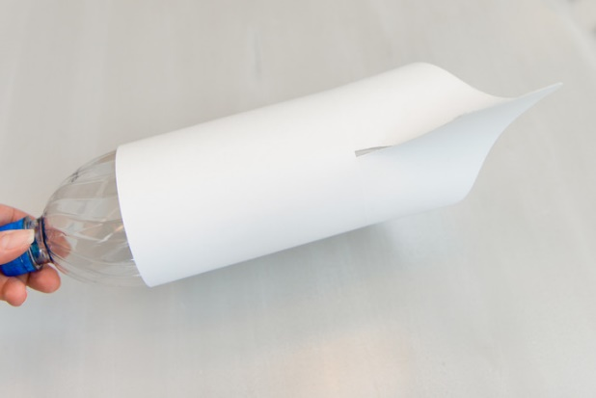

4. Draw and Cut Two Engines
Draw two identical rectangles about 4 inches long and 1 inch thick on card stock paper. These are going to be your engines. Cut the rectangles out and then roll them into long tubes.
Tape the tubes, and then attach them to the plastic bottle, one on either side. Note: You want your tubes to touch the “ground” because the engines also serve as “feet” to stabilize the plane piggy bank.

5. Draw and Cut Two Wings
Draw two identical triangles with rounded tips on your card stock paper, which will become your wings. Cut them out and attach the wings above the engines. Tip: It helps to fold a tab on the long edges of the cones for easy attachment.

6. Draw and Cut the Plane Propeller
Using the bottle cap as a guide, draw your plane propeller. The bottle cap is going to secure the propeller onto the bottle, so you want the circle opening to be slightly smaller than the cap so it doesn’t slip over it.

7. Add Any Details
You now have a basic plane, but you can add some personality with extra card stock paper! Draw, cut out and affix windows and back wings. Let your child flex their creative muscles and draw faces in the windows.

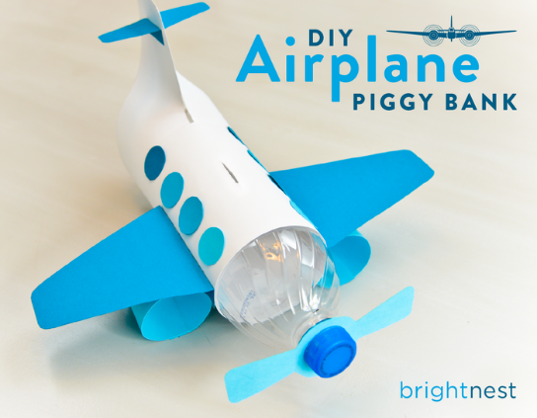
11- Sand Paper T-Shirts
Supplies for Sandpaper Prints
good quality crayons, a t-shirt, iron and fine sand paper. Our package of sandpaper had a selection and we used the finest. The more coarse sandpaper will provide more texture.
Have the children color a fun design on the sandpaper. Remind children that the image will be reversed. Once the design is colored go back over the design giving the sandpaper an extra thick layer of crayon.
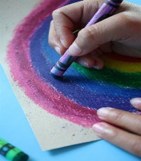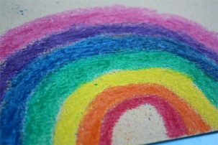
Place a piece of cardboard inside the t-shirt to keep the design from bleeding through to the back of the shirt. Position the sandpaper right side down on the t-shirt.
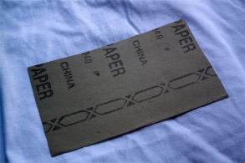
Place a piece of parchment paper or paper towel on top of the sandpaper to protect the iron. Iron, on cotton setting, the sandpaper for about 30 second. Gently lift one edge and make sure you have a good print before totally removing the sandpaper. Iron a bit more if you need to transfer more of the crayon.
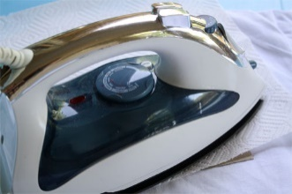
Remove the sandpaper. You’ll have a print with loads of cool texture–not to mention a new darling t-shirt.
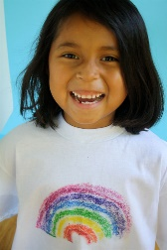
To set the color, place a couple of paper towels on top of the design and iron. This will remove some of the extra wax. Toss t-shirt in the dryer for about 20 minutes to set the color. Launder by itself the first time.

12- 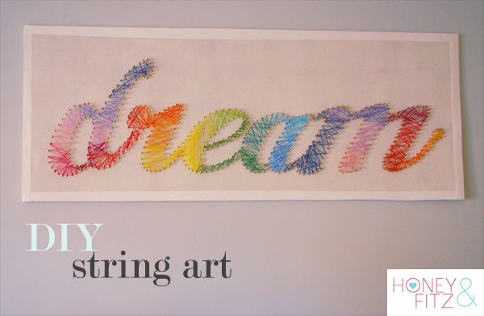

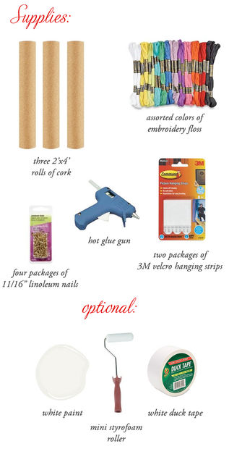
{Before I started this project, I unrolled the cork boards and placed a bunch of heavy books on them to straighten them out a bit. I left them like this for a day.}
Each piece of cork board is only about 1/32" thick - definitely not enough to hold a nail stable. So I stacked three together. Use your glue gun to glue them together. Put them back under some heavy books for an hour or so so allow to dry completely.

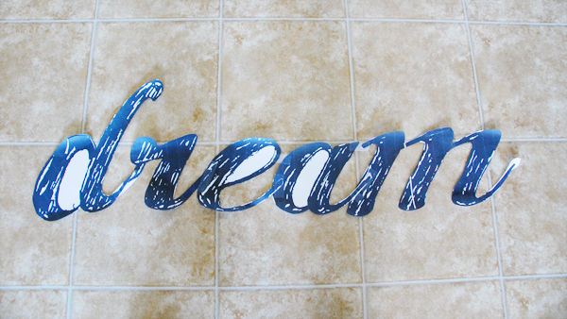
You can download my template for the word "dream" here. The "d" and the "m" will print in two parts on two different sheets. Cut them all out and assemble into a single word using some Scotch tape. It should look like this when you're done.
Reinforce the spaces between the "e" and "a" and "m" with some additional tape. That will make the entire template more stable to work with. Don't worry about cutting out the inside of the "d", "e" and "a". Not necessary!
Center your template out on your cork board. I decided there was too much cork at this point and wanted to trim away a few inches from the top and bottom.
IMPORTANT! DO NOT TRIM THE CORK BOARD WITH A BOX CUTTER! IT WILL TOTALLY SHRED AND FALL APART ON YOU. USE SCISSORS AND IT WILL CUT NICELY WITH MINIMAL SHREDDING.
I really wanted the look of a white background for my string art so I decided to paint the cork. If you're fine with the cork color/texture background, then feel free to skip this step. I used some leftover latex paint I had (BM Sea Pearl if you care) and a Styrofoam mini roller. Nothing special.
When the paint dried, there was a little bit of buckling of the top layer of cork board and I could see where I had missed spots with my hot glue. Don't worry if this happens to you, it's completely not noticeable after you're done.
At this point you'll want to flip the entire canvas over and apply your hanging strips. Do this now so that you don't have to deal with it once all your nails are in.
Center your template and tape it down.
Insert your nails into the cork, following the outline of your template. They should push in fairly easily with a little pressure (except when you hit a glob of hot glue below...then you'll need to push a bit!) Trace the inside of the "d", "e" and "a" by pushing the nails right thru paper.
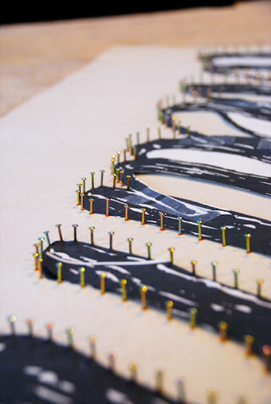
When you've traced the entire template, carefully remove the paper. Work slowly and you're nails will stay in place.
Here's my canvas ready for stringing! I actually thought it already looked pretty cool at this stage.
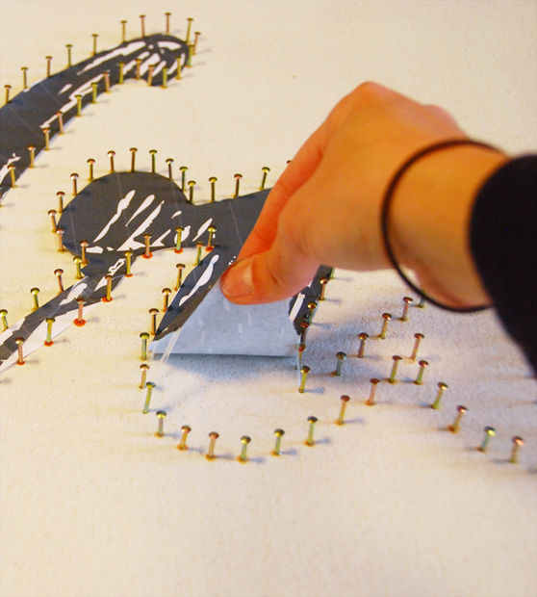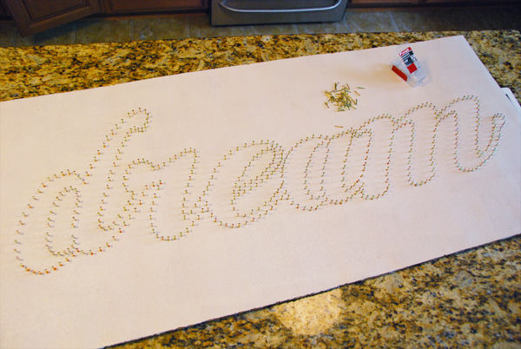
Now the fun part - stringing! I decided to do this in a rainbow spectrum effect but you could easily do it in all one color as well.
Starting with my dark purple, I tied onto a nail at the top of the "d".
Now you're on your way! Just start weaving in a back and forth fashion. The less you think about this the better. I actually found it to be quite therapeutic. Just let it flow. If you don't like the way a certain section looks, unwind and do it again. It's very forgiving!
I kept moving through the color spectrum as I worked my way through the word. I found that overlapping the colors a bit helped to blend each color into the next.
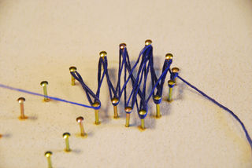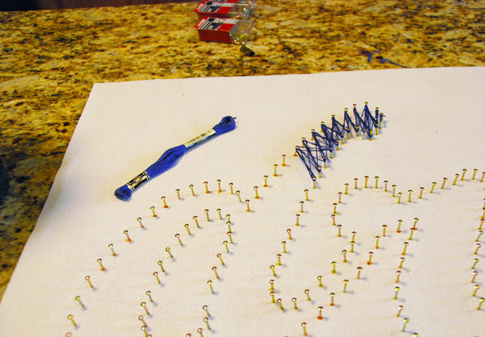
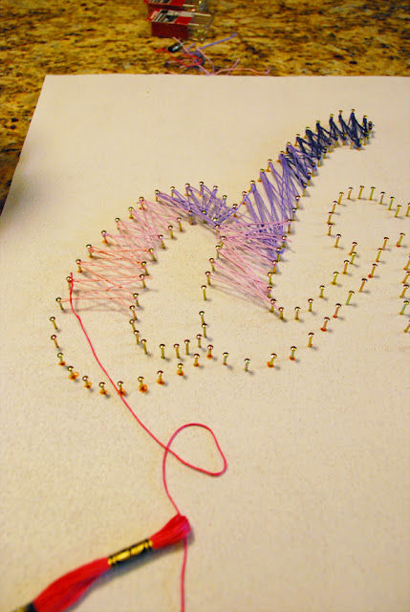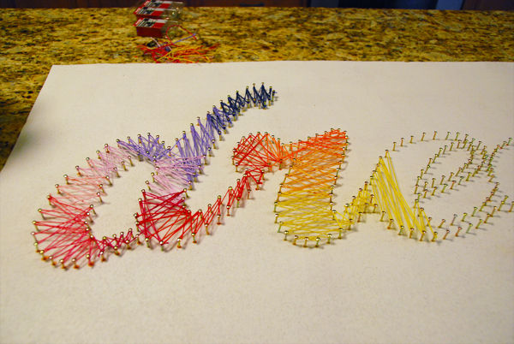

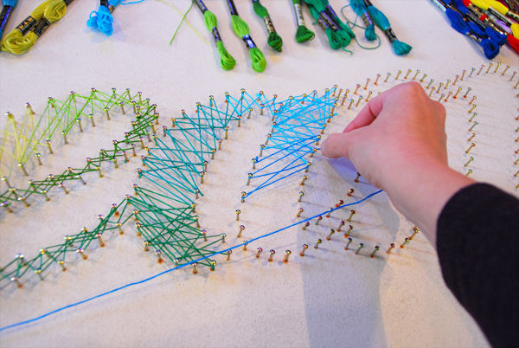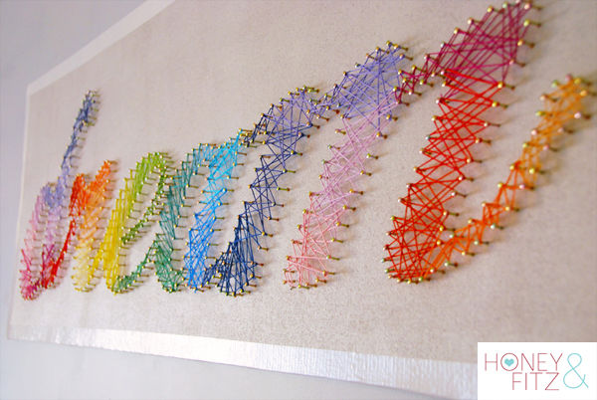

13- Tye Dye Pillow Case
What you will need
- 1 pillowcase
- 4 different colors of Rit® Dye
- Rubber bands
- Hot Water
- Plastic squeeze bottles
- Potholder
- Scissors

First, be sure to wash and dry the pillowcase, but do not use fabric softener. Lay the pillowcase on the work surface.
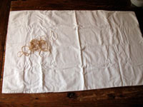
- Have the child gather the center of the pillowcase in their hand and wrap a rubber band around it, leaving about an inch of fabric exposed at the top, as tight as they can without breaking the rubber band.
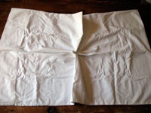
- Continue adding rubber bands around the pillowcase, leaving a two-inch space between each one.
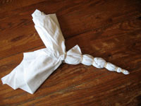
- When you get to a point that the ends of the pillowcase split, wrap rubber bands in the same fashion on the two different sections.
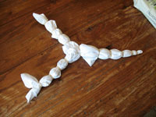
- Soak or dip the pillowcase into warm water to saturate the fabric. Squeeze out the excess water. This will make it easier for your dye to soak in
- Mix dye according to package directions and pour into plastic squeeze bottles. Note: We used 1/4 of the package for each color, with 1/4 of the suggested amount of hot water. So in other words, we could do 4 pillowcases with 4 different colors of dye.
- The plastic bottle will be hot, so use a potholder to grab the bottle with. Have the child squirt the first color onto the first section of exposed fabric. Be sure they saturate the fabric, taking care not to drip onto the next section. If they do, don’t be concerned, you will not notice these little marks in their finished product.
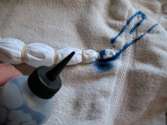
- Skip 3 sections then squirt the fourth section with that color again. Repeat until you have the first color on every fourth section.
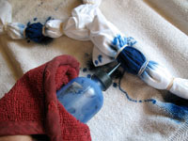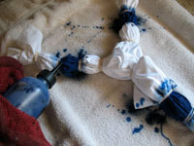
- Mix dye for second color and add to a clean squeeze bottle. Dye the second section of fabric, and repeat the pattern you did with the first. Repeat these steps for the remaining two colors. Allow the dyed fabric to sit for 30 minutes or longer.
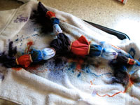
- Rinse the pillowcase first in warm water, then gradually reduce the temperature of the water, rinsing until the water runs clear. Squeeze out the excess water.
- Carefully cut the rubber bands, making sure you don’t cut the fabric as well. Remove all of the rubber bands and open up the pillowcase. For the first time, wash the pillowcase in cold water with only a small amount of soap; a teaspoon of soap per pillowcase is plenty.
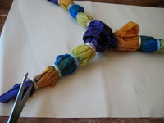
Tip: We used plastic squeeze bottles from a salon supply store, but you can also find them at craft supply stores. You can also purchase tie dye kits at the craft supply store that come with everything you need, including rubber bands, dye and bottles. Tie dye kits will provide more vibrant color that will not fade like Rit dye can.

14- Water Bottle Flowers
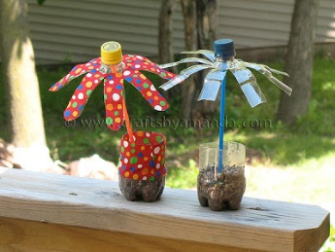
What You Need
Plastic single serve water bottle with lid
White craft glue
Scissors
Sand or soil
Pebbles or rocks
Drinking straw or twig
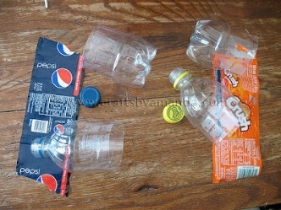
Have the children remove labels and lids, but don’t throw them away. We will be using the entire water bottle! If your water bottle does not have a label, have a bit of scrap paper nearby to use instead. Cut the water bottle in half, put the bottle half aside.
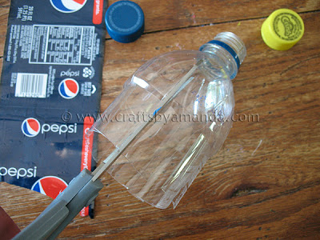
Then have them cut slits, about an inch or so wide, in the top half of the bottle. They should end up with 8 “petals”. Bend the petals outward.
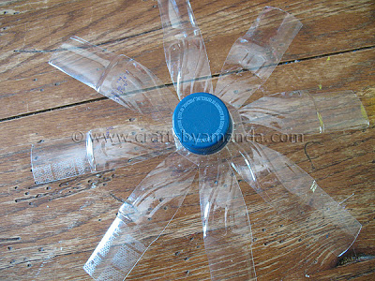
Put the lid on the bottle top.
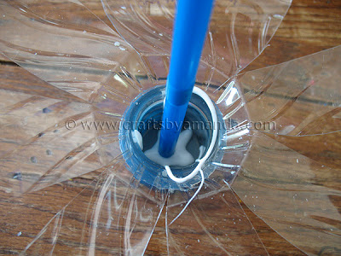
Then they will squeeze some white glue into the lid and insert the straw or twig into the glue.
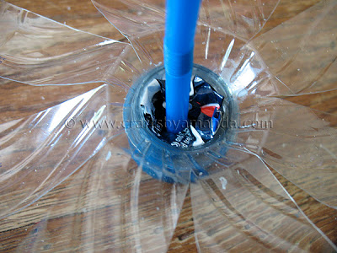
Next, have them wad up the bottle wrapper and surround the straw with it, to help give the straw stability.
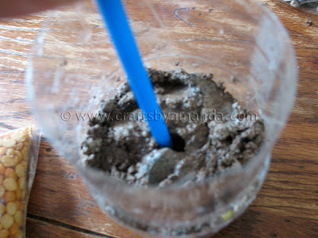
Put some sand or soil into the bottom half of the water bottle, about 1.5 – 2 inches in depth. Pack it down a bit and insert the bottom end of the straw into it.
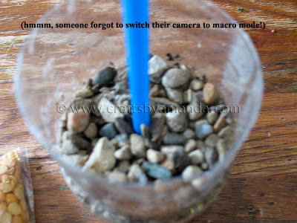
Add pebbles or stones on top of the sand to help stabilize the straw (stem).
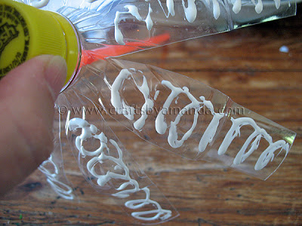
Optional: If you like, cut strips of fabric to decorate the flower petals and the flowerpot. You can also round the petals by trimming the ends with scissors.
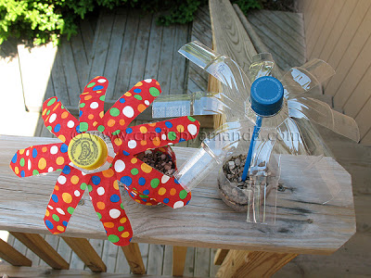

15-Crystal Names
Need
Pipe Cleaners
Scissors
Borax
Food Coloring
Liquid Measuring Cup
Tablespoon
Heat Safe Mixing Bowl
Plastic Show Box (1 per color)
Tape

Shaping The Names
Have child form name with pipe cleaner. The name has to fit in the bowl without touching any sides. Older children could connect a few pipe cleaners and do their name in cursive.
Tie the yarn to the childs name.
Figure out how much boiling water your container will hold then you know how much borax you will need. For every 1 cup of boiling water you need 3 tablespoons of borax.
Boil Water
Pour Borax and a few drops of food coloring inside the plastic container
Pour Boiling water into plastic shoe box and stir until borax is dissolved
Take the yarn with the hanging letters and tape one end to the side of the plastic shoe box then the tape the other end across from it making the letters soak in the borax food coloring mixture. Don’t let the letters touch the sides or bottom of the container.
Let sit over night or as needed for crystals to form.
See Picture!

16-Kaleidoscope
Need
- Clear Lids
- Tissue Paper
- Ribbon or Twine for Hangers
- Beads or Jewels
- Glue
Put 2 lids together and hole punch
Put glue on one lid and then and add thin layer of tissue paper
Make sure there is boy and girl color tissue paper.
Make sure glue is dry before adding beads. Add another lid hot glue it to the decorated lid. Put name date on the side.
Boys use twine and girls use ribbons cut strip and loop through the hole for hanger
17-The Lemon Art Project
Read the book The Little Lemon that Leapt to your class and discuss with the children. Ask for feedback.
Make the lemon look like an image (likeness) of you or a caricature of you.
Tools to use
- Permanente Markers
- Yarn
- Material Scraps
- Wall Paper Scraps
- Buttons
- Hot Glue or Tacky Glue
- Index Cards
- Newspaper

This is not to be perfection but fun.
car·i·ca·ture
a picture, description, or imitation of a person or thing in which certain striking characteristics are exaggerated in order to create a comic or grotesque effect.
"a caricature of Jimmy Durante"
synonyms: | cartoon, parody, satire, lampoon, burlesque; More

First have children write their name and date on the index card.
Then let the children roll up news paper to make a small ring and glue around the bottom of the lemon then glue newspaper lemon to the index card to make it stand.

Encourage the children to talk about what they are going to do. They can even draw it out on a piece of paper. (Do not let the children start haphazardly without a plan. Then let them decorate the lemons themselves.
18-3D HAND ART
Materials
Markers
Pencil
Ruler
Piece of Paper

Trace your hand (and a bit of a wrist) using a pencil. Remember to do it lightly.
Now take a marker and a ruler and draw straight lines across the paper to an outline of your hand. After that point, draw a curved line to the next point on the outline and then continue with a straight line.
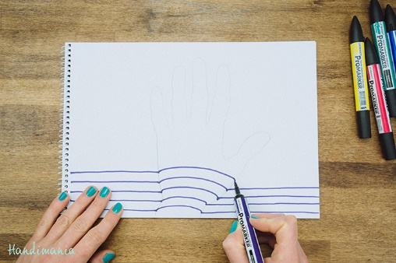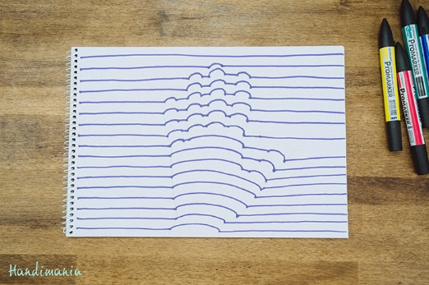
It’s time to make your 3D hand more lively! Take at least 3 markers in different colors and fill the gaps between basic lines by drawing lines in between. Always repeat the same order of colors. If it’s necessary, fill any white spots you missed.
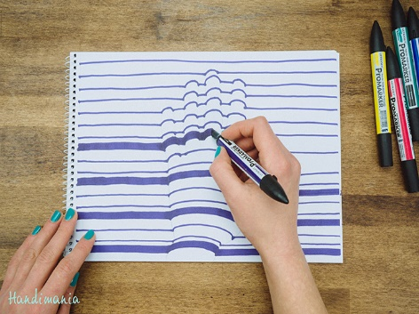
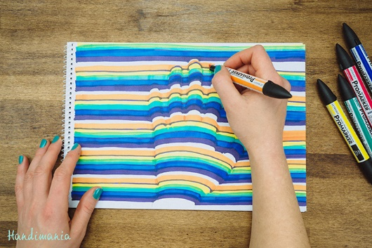
Look, the 3D hand you’ve just made is about to pop out of paper!

19-Birdfeeders

Wooden Spoon Feeder
A plastic soda bottle and a couple of wooden spoons make a great birdfeeder. You just have to make holes in the bottle for the spoons and be sure that you angle the spoons downward so that the birdfeed will drizzle onto them. This is a really cute idea and a great project for the kids.
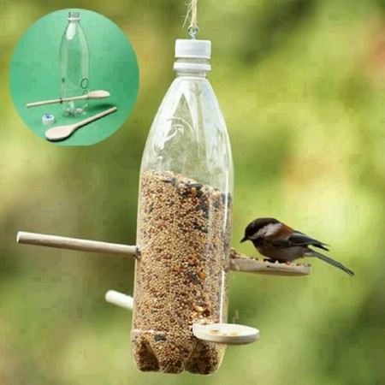

Milk Carton Feeder
An old milk carton will make an adorable feeder. You can paint (or have the kids paint) a cardboard milk carton and then just cut a hold for the feed. You may want to put a wooden dowel or even a wooden spoon through so that the birds have somewhere to land when they want to eat. These are really easy to make and are great for kids to do.
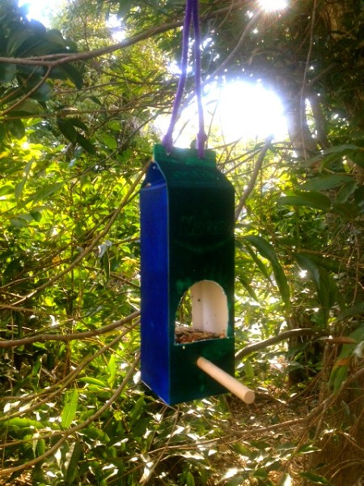

Pinecone Feeders
Pinecone feeders are sort of traditional. You can spread them with peanut butter and then add birdseed or spread them with lard and add birdseed. Whatever you prefer, these are really easy to make and are great projects for the kids. Make several of them and decorate your outdoor trees with many little feeders.
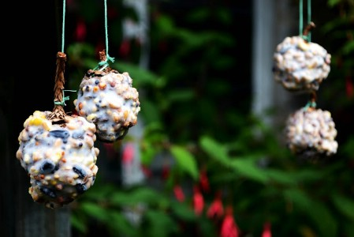

Window Birdfeeder
If you love looking at birds in the winter but simply don’t want to go outside to do it, you can bring them right up to your window. You just need a few scraps of wood and a glass-safe hanger. Just create a little “house” for your birds and then attach to any window. You can then sit inside your warm and comfy house and watch the birds eat all day long.
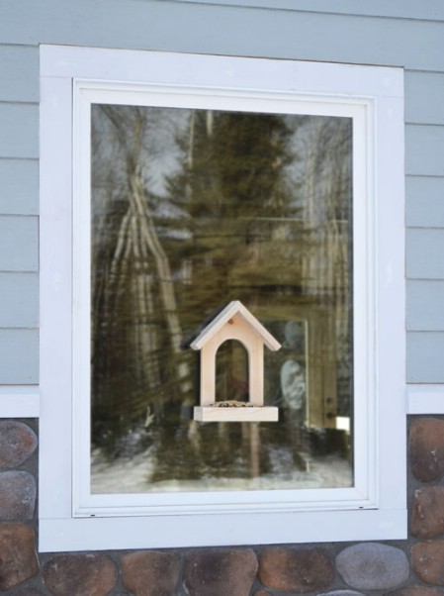
Egg Carton Birdfeeder
Materials
Egg Carton
String
Scissors
Glue
Bird Seed
Instructions
1. Carefully cut off top of egg carton and punch hole in four corners
2. Cut two pieces of string about a foot long each.
3. Thread string through holes diagonally and tie ends into knots over corners. Use a dab of glue for extra security.
4. Add bird seed and enjoy the birds!
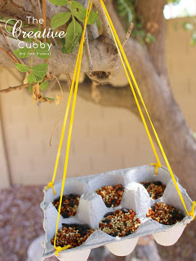

20-Easy Photo Transfers on Wood

Ingredients:
Mod Podge
Pictures
Sissors

You will need to trace around the wood slice and trim down the photo to fit onto the wood slice.
Cover the wood slice in a good layer of regular mod podge
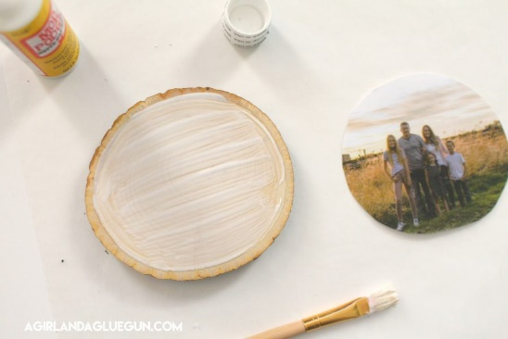
Lay over the photo onto the mod podge and press to get out all the bubbles and wrinkles. You can put something heavy over to keep it smooth. And then wait 24 hours. (I HATE WAITING!) but well worth it!
After 24 hours you get the paper damp and rub off the paper. the mod podge keeps the photo onto the wood and you only take off the paper. It’s PRETTY COOL. The paper takes awhile to get off.
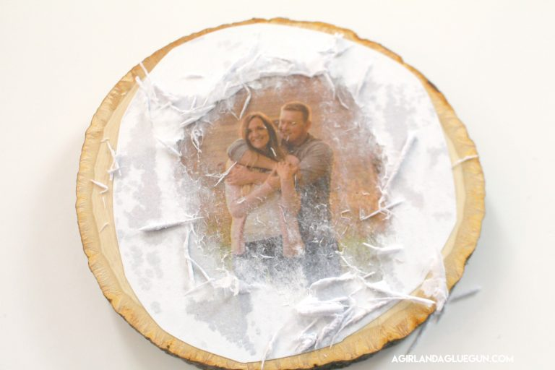
You think you have rubbed it all off…and after it dries the paper shows up. You just get it damp again and rub it off! (also…see the little missing piece on the right? That is a bubble where the paper wasn’t totally down flat!
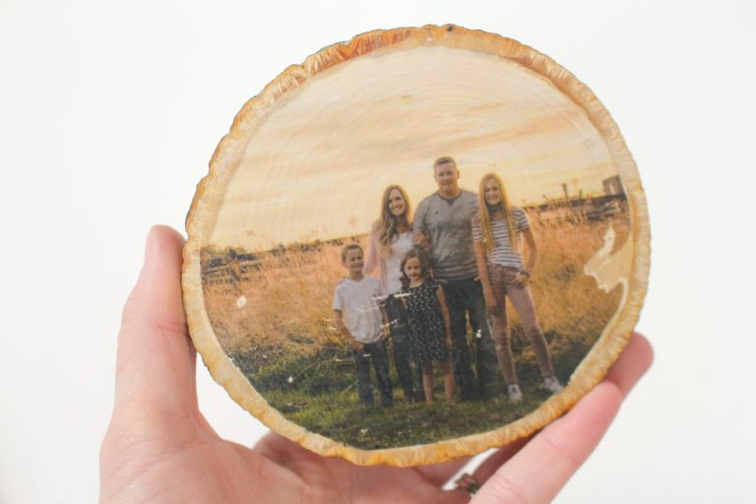
21-French Knitting

Materials:
- 1 toilet paper roll
- glue
- six Popsicle sticks
- a few rubber bands
- ball of yarn (different colors are always fun!)

Instructions
  - Glue six craft (Popsicle) sticks around the tube so that their ends stick out beyond one end. (This can also be these done with three or four sticks.)
  - Wrap a couple of rubber bands around the tube to stabilize the sticks.
  - After the glue dries, thread the yarn through the tube from top to bottom, so the loose end is sticking out the bottom of the tube.
  - Loop the yarn around each stick, so that the yarn crosses behind the sticks.
  - When all of the sticks have a loop of yarn, wrap the yarn around all the sticks, in one loop, and begin lifting the bottom loops over the new loop.
  - As you continue wrapping around all the sticks and lifting loops over the top, a tube of knitting should descend through the tube and out the bottom.
Pics on next page

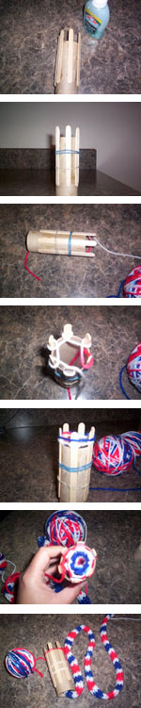

22- Matisse egg

Materials
Cardstock
Sissors
Balloon
Mod Podge
Cup

Cut out different shapes with the cardstock. Blow up balloon and put in the cup.
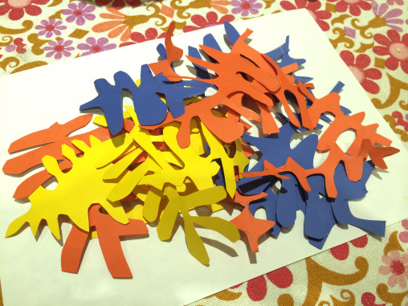
Start gluing shapes on the balloon with the mod podge.
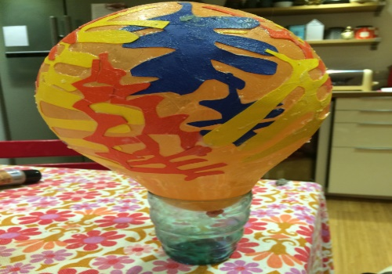
Let the balloon dry overnight and pop the next day.
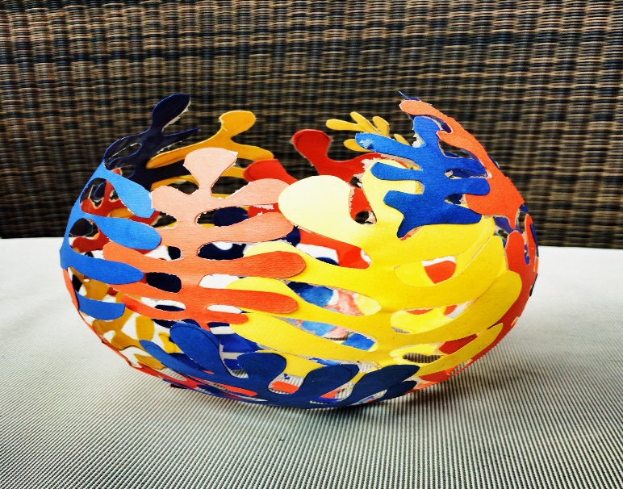
23-No Sew Blanket
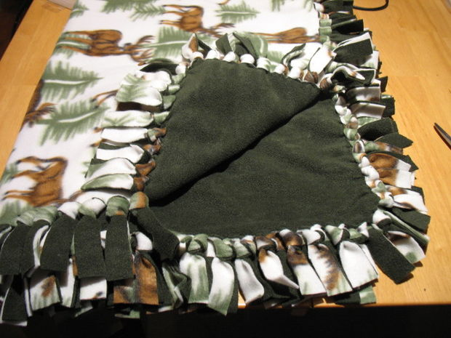
Line up the two fabrics, right sides OUT. Anti-pill solids are FUZZY on the right side. Anti-pill prints will be more distinct on the front side. Regular prints are hard to tell -- use the side that appeals to you.
Trim the two pieces so that they are the same size.
Cut a 5-inch square from each of the four corners.
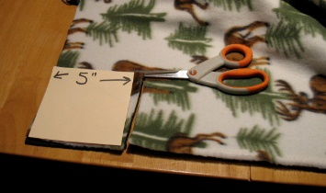
Cut fringe on all four sides of the blanket. Cut through both layers of fabric at the same time. Fringe pieces should be a little wider than the width of your finger. Cut in from the edge 5 inches. I like to lay a yard-stick across the fabric, 5 inches from the edge so that I know how far in to make my cut.
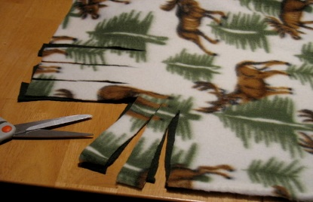
Leave your blanket laying flat on the surface, with all fringes lined up. I find it easier to start tying from the left and work right, going around the blanket. If you are left-handed, you may find it easier to start on the right and work left. These knots are called balloon knots... tie them just like you would if tying off a balloon! You can also tie a knot like you would make with a shoe lace.
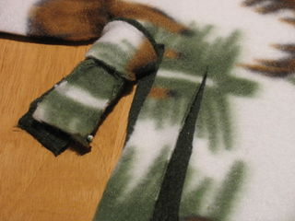

Continue around the blanket

Tie all the fringes together on all four sides of the blanket. You are Finished! Wasn't that easy? All the knots should be snug up to the blanket, but not too tight. The finished blanket should lay flat.

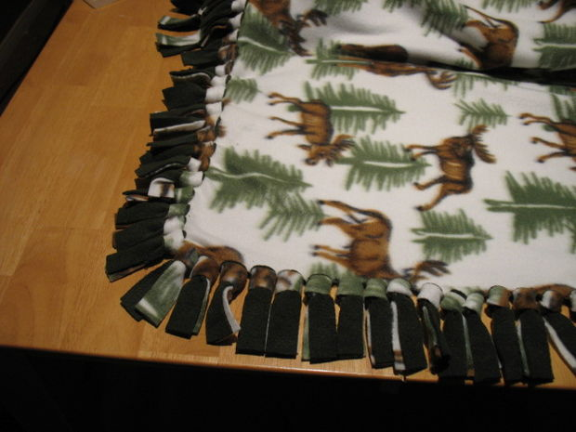

24- Old Tshirt Pillow Cases

TOOLS
- scissors
- rotary cutter

MATERIALS
- t-shirt (size XL works best)
- yard stick
- stuffing
pins

Lay Shirt Flat and Pin
Lay the t-shirt graphic-side up and pin both sides together with four to six pins.

Cut Out Graphic Area
Cut widely around the logo leaving as much fabric around the graphic as you can.
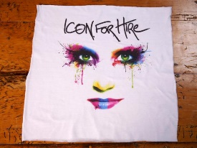

Fold and Cut Small Square
Fold the t-shirt into fours. Cut a 2” x 2” square out of the top right corner through all the layers of the fabric.
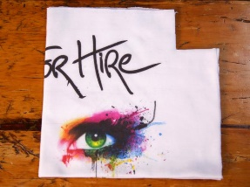

Unfold and Cut Small Strips
Unfold the t-shirt and cut strips 3/4” wide and 2” long in both layers of fabric.
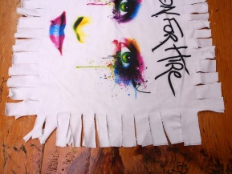

Tie Strips
Knot each pair of fringe all the way around. Make sure to leave about five tabs unknotted so you can stuff the pillow.
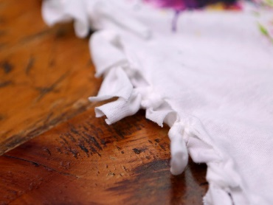

Stuff Pillow and Tie Off
Stuff the pillow with cotton batting or old fabric. Tie the remaining tabs to close up the pillow.
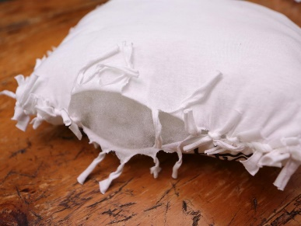
ALL DONE
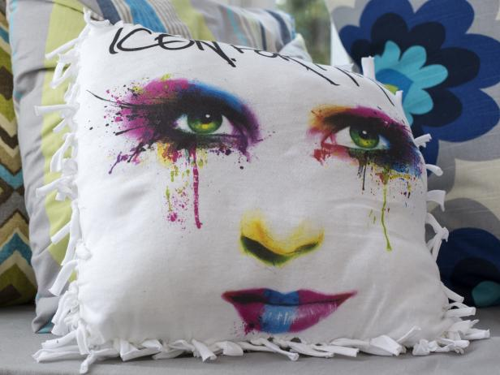

25- Old T-shirt Potholder

TOOLS
- scissors

MATERIALS
- no-slip rug pad with holes in it
- pencil or other pointy object
- (5-7) t-shirts

Cut Strips
Cut the t-shirts into long 1/2" strips.

Cut Strips into Shorter Pieces
Cut the strips into 5" pieces. There is no need to be specific, simply eyeball it.

Thread Strips into Rug Pad
Use a pointy object — like a pencil — to push one end of a strip through the holes on the bottom of the no-slip rug pad.
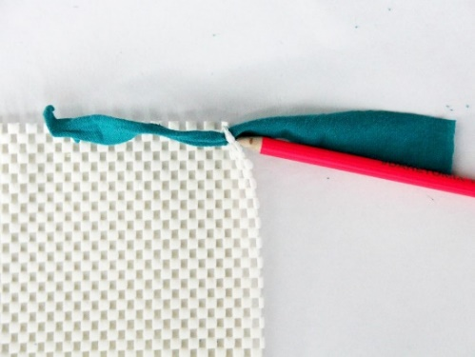

Knot Each Strip
Tie the fabric strip in a knot.
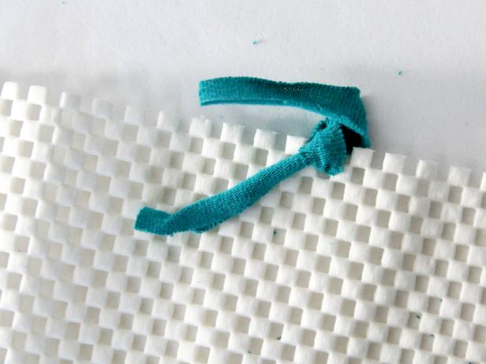

Fill It In
Repeat the previous steps, pushing the strips through all of the holes on the no-slip rug pad until it is completely covered. Double up on the strips for a fuller rug.
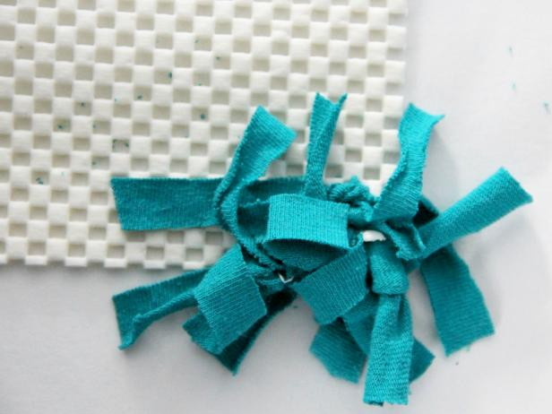

26- Popsicle Stick Bracelets
Tongue Depressors /Popsicle sticks / Craft Sticks
Paint
Mod Podge / Vanish
Glass - oven or microwave safe.
Rubber bands or string
Some might say it's not necessary to soak over night...well ...not if you want to use 100% of your sticks!
Soak your sticks over night to soften the wood...you will notice that the wood will curve slightly..that is good..so when you bend...bend in that direction.
Once you have soaked it overnight...boil for 30 minutes......get all your glasses lined up and a glove...you don't want to burn you fingers!:-)
Take one stick at a time and gently bend them and slip them into the glass...it's okay if the glass is smaller than your hands...when you paint it might get wider.
I would not recommend switching off the fire... as when it's let to cool while you do your stick....your last few sticks might break...learned that with my last stick! but no problem...you can simply sand it...you will notice it came out okay from my pictures...so yeah 100% success!
Now stick your glasses in the microwave for 1 minute or so...once the water is absorbed you can just slip your bangle out!
Now paint!
While painting ...you would notice that some of the bangles will be getting wider again...well no fear...for this you could either drill 2 holes at either end and tie with a string...or you could place it in the glass again...then (in both ways) microwave it for 1 minute ...
Done!
Varnish if you like :-)
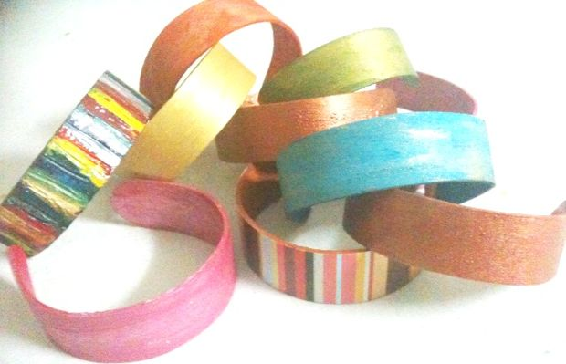
27- Screen Print T-Shirts
Materials
Shirt
modge podge
fabric paint
children’s design
cardboard piece
embroidery hoop
nylon or panty-hose fabric
paintbrush
permanent pen

Instructions
1. Create a design for your screenprint. I started with something simple since it was my first time using this method. Later, I did a more elaborate design for the front of the shirt, after I did this first heart as practice. Make sure that your that your embroidery hoop is large enough for your design.
2. Stretch the nylon over the hoop so that it is taut.
3. Trace your design using a a permanent pen.
4. Using Mod Podge, paint the "negative space", or, the space that you do not want to be painted.
5. Fill in the whole area, making sure there are no holes or gaps. I was obsessive about this because I didn't want the paint to seep through. Let dry completely. It took about 3 hours for this little one to dry.
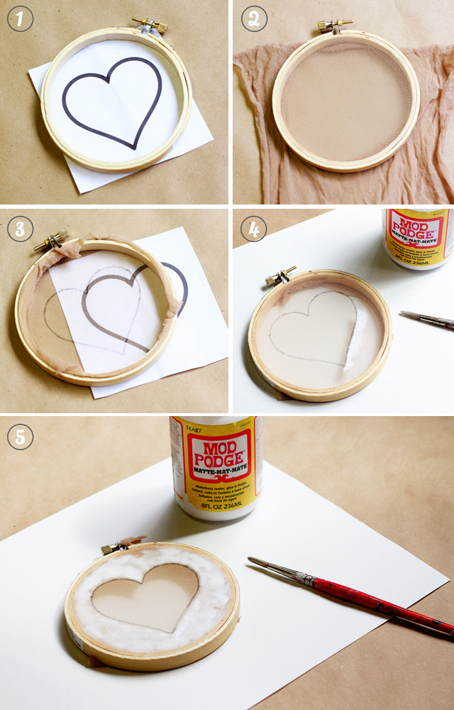
6. Lay the hoop flat on the shirt and position where you want the design to be, and place a piece of cardboard beneath the area so that the paint doesn't bleed through the back. Squirt a generous amount of paint over the design.
7. Use the cardboard to spread the paint over evenly.
8. Carefully lift the hoop off the shirt and voila!
9. Let the paint dry completely before wearing.

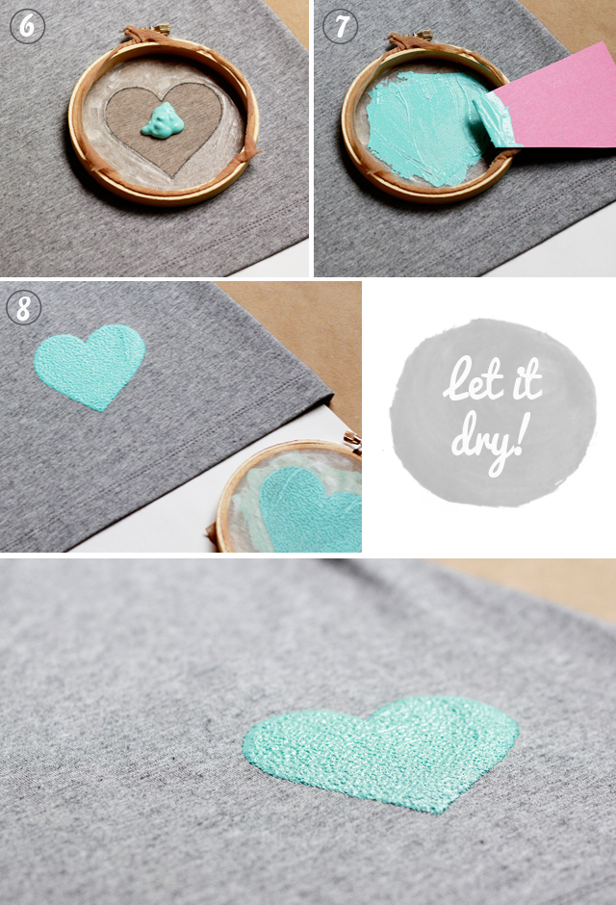

28- Shibori Dying Technique
SUPPLY LIST:
~ Indigo dye kit
~ White 100% cotton t-shirt (or napkins or any white fabric)
~ Rubber bands
~ Wooden blocks, clothespins, corks
~ Large bucket or pot for fresh water
~ Large 5 gallon bucket with lid for indigo dye
~ Stick for stirring
~ Tarp for drying
~ Scissors for cutting off the rubber bands

Tie up shirts with rubberbands using corks, wooden blocks and or clothespins
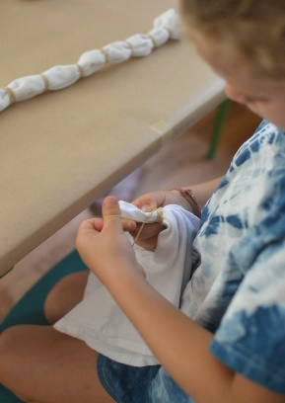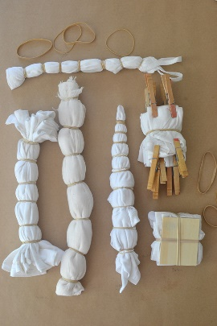
~ After tying up your t-shirt, it needs to be soaked in some water. But before heading over to the buckets, I gave each kid a pair or rubber gloves!
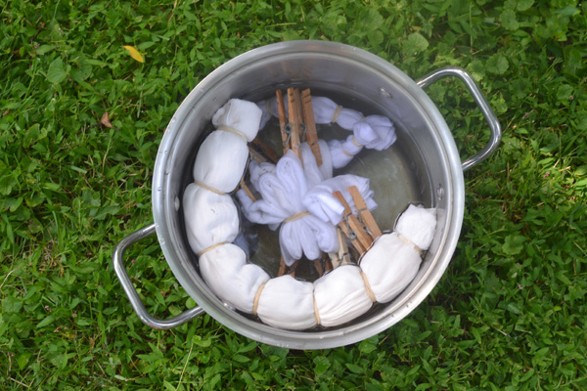
~ After the fabric is nice and wet, squeeze it out a little before gently placing it in the dye bucket. Once in the dye, the kids had fun pushing down and swirling around their fabric. They did this for about 10 minutes.
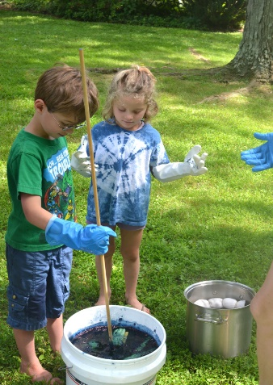
~ Then it’s time to pull it out of the dye, squeezing out as much indigo as possible. It’s really cool because the color at first is a bright green. The indigo reacts to the sunshine and turns blue within a few minutes. That part was really fun to watch.
~ Rinse the fabric a few times in fresh water, until no more dye runs out (or almost no more).
~ We dried ours for a bit on a tarp. Then, after everyone had dyed their piece of fabric, I cut off all of the elastics with scissors then hung on a line to dry.
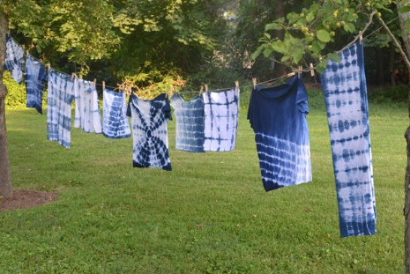
29- Shrink Charms

This is what you'll need:
- Clean transparent plastic packaging, e.g. takeout boxes
- Scissors
- Hole puncher
- Colored permanent markers

This is how it's done:
Before working with the plastic packaging you should clean it thoroughly. Then you can cut out a large, flat piece, e.g. the bottom of the takeout box.
Find some nice designs or cute images that you would like to use. These can be found online and printed out. Keep in mind that the images will shrink by up to 70% in the oven, so make sure they are large enough. Now lay the images under the plastic and copy them using the colored markers. It's best to use a black
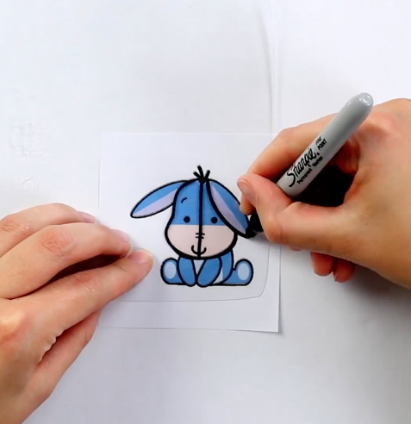
The next step is to color in your image and punch a hole at the top. This hole will be used to attach the charm to a bracelet or to make a necklace. Now cut out the image making sure not to cut off the hole.
Place the plastic on a baking sheet and bake it for two to three minutes at 330 °F. You'll notice that the plastic begins to curl and crumple but don't worry, this is completely normal. When it is finished baking it will be flat again.
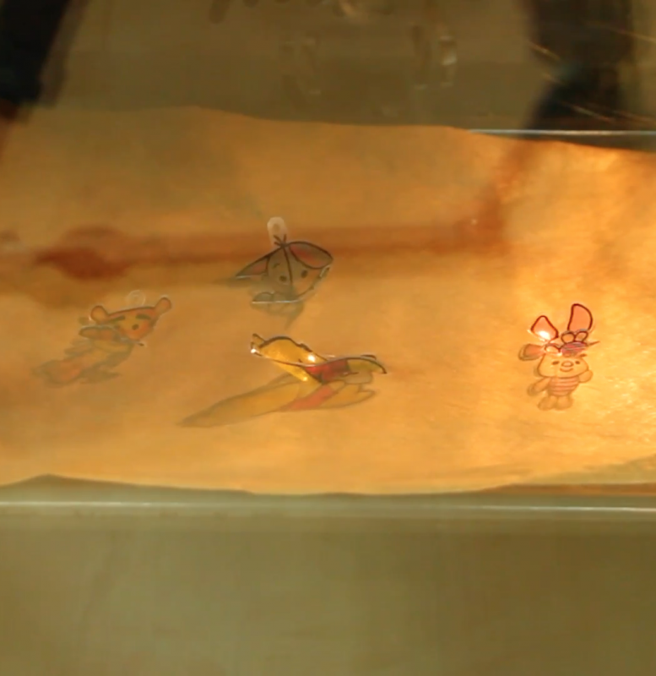
Now the plastic is smaller and thicker which makes it more stable. You can use metal jump rings to attach the charms to a piece of jewelry.
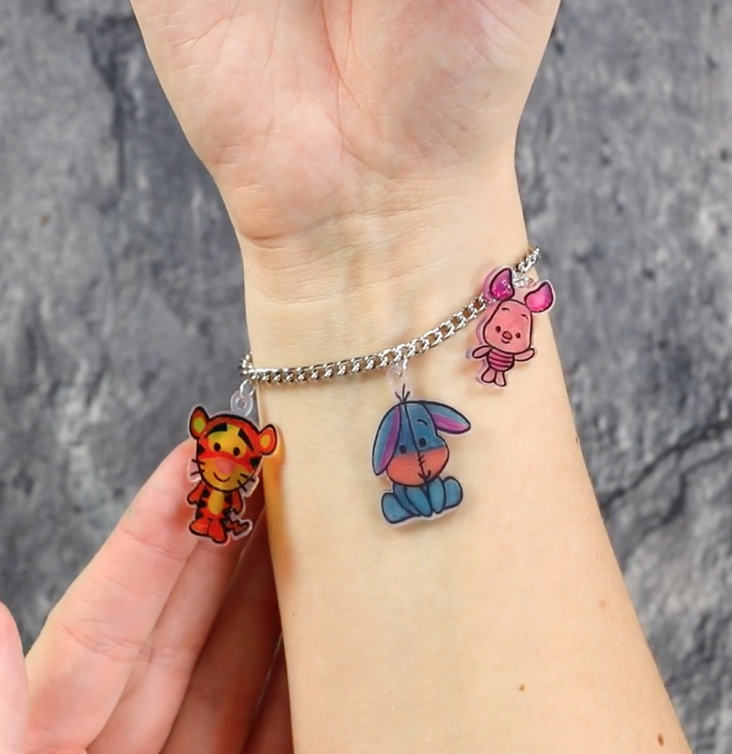

The best thing about these shrink charms is that you can make them into any shape you like — candies, cartoon characters, words and quotes — let your imagination run wild!
30- Weaving
To cast on, begin with the palm of your hand facing you with the tail end of the yarn between your thumb and index finger. Weave the yarn over your index finger and behind the middle finger then over the ring finger. Wrap the yarn around your smallest finger and weave back to your index finger.
Fig 1
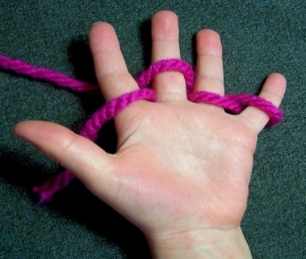
Weave the yarn around the index finger again and continue in the same manner but above the first rows of stitches returning to your index finger again (see fig 2).
Try to keep the stitches fairly loose otherwise it will be difficult for you to make the following moves.
Fig 2
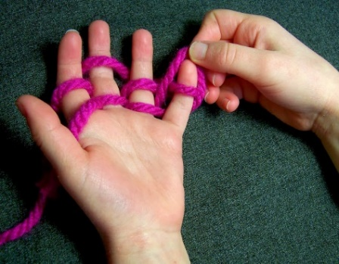
The first row, begins with the little finger, lift the bottom row of wrapped yarn up and over the tip of your finger (see fig 3). Ensure that you keep the top row of wrapped yarn on your finger as you go.
Continue the process of lifting the bottom row of stitches over the top row of stitches along your hand until you get back to your index finger.
Fig 3
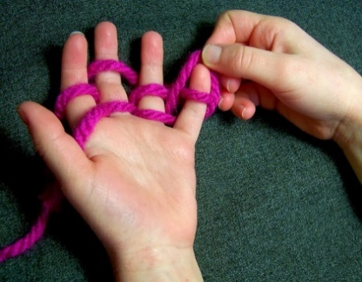

For all subsequent rows, weave the yarn around the fingers again ending with the index finger as you did in fig 2. It should look like the image in Fig 4, and then lift the bottom row of wrapped yarn over the top as you did in fig 3.
Fig 4
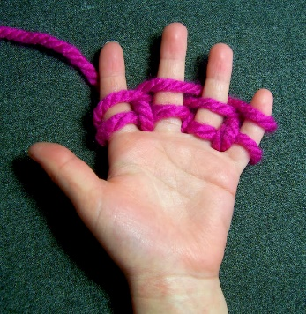
As you continue the process you will see a long strip of stocking stitch appearing behind you hand (see fig 5 Below).
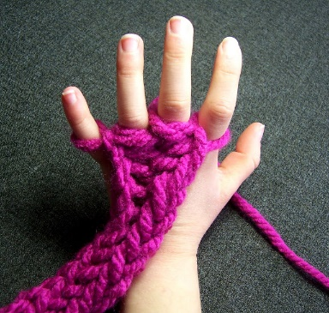
Continue until your work is approx 20cms in length then cast off. To cast off, do not weave the work around your fingers instead, lift the stitch off the little finger and pass it across to your ring finger (see fig 6) then lift the bottom stitch over the top stitch on your ring finger. Continue to pass the stitches across and over until you get to the index finger with one stitch remaining.
Fig 6
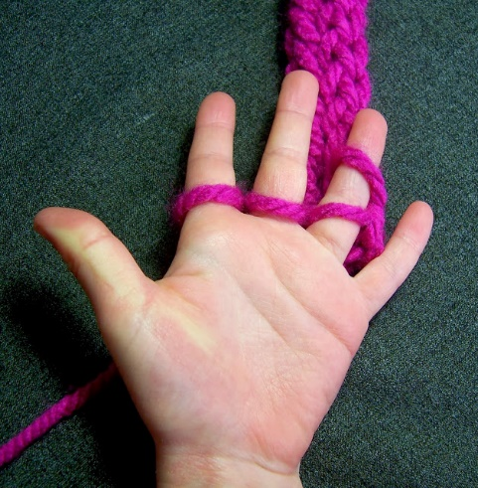

255

